PSP0201

Week 2

(DAY 1)

Writeup

Day 1: A Christmas Crisis

Copy and paste in the IP Address listed at the top of the task into the browser search bar

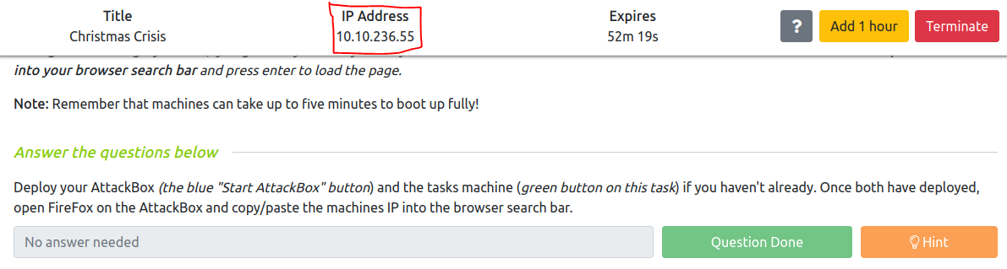

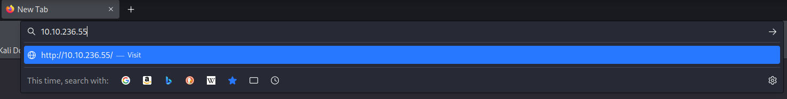

The Christmas Control Centre will be shown and we can start  


Register for an account, and then login, the console page will load up

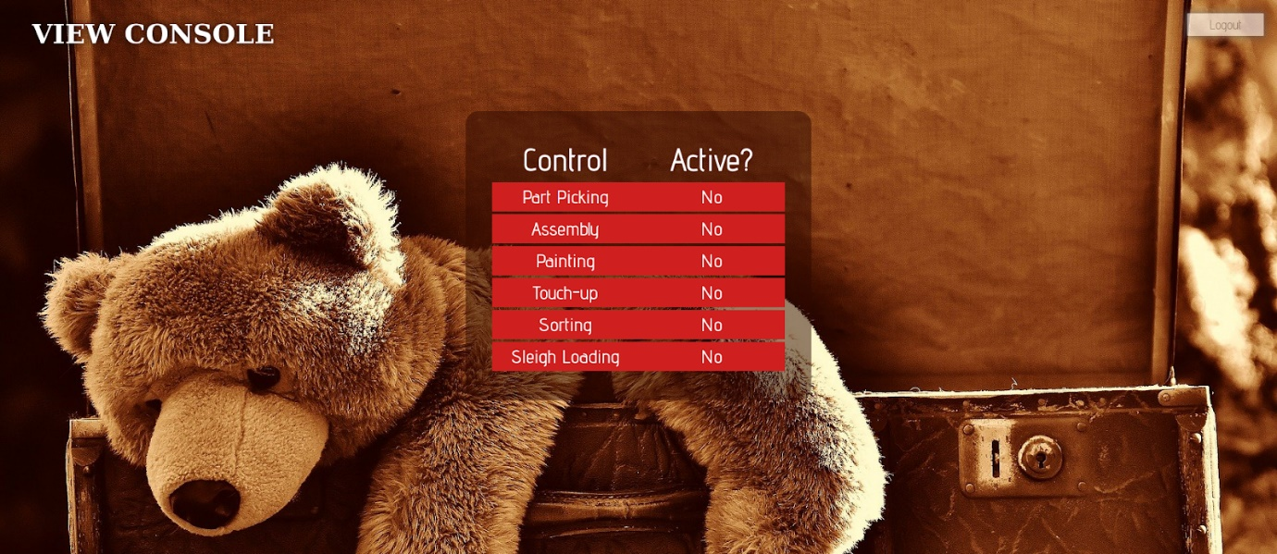

We are unable to control or activate anything on the panel

Then we can press F12 on our keyboard to open up the Browser Developer Tools panel.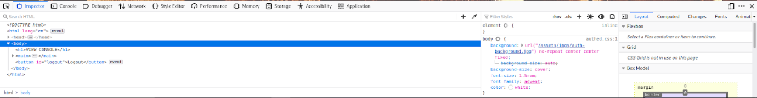

Click on the storage to search up our cookies used on this website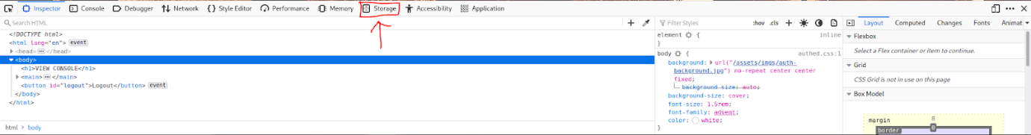

This section should pop up and we can use the information to gain access to the console panel.

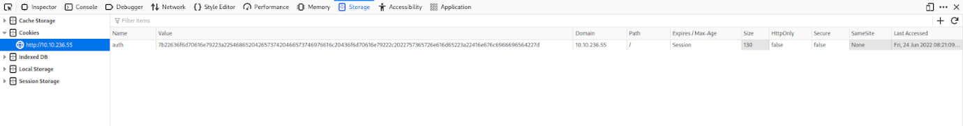

Question 1: What is the name of the cookie used for authentication?  
Answer: auth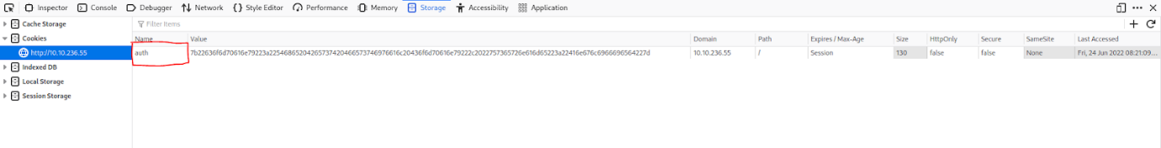

Question 2: In what format is the value of this cookie encoded?

Answer Hexadecimal

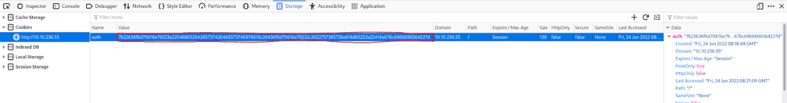

Question 3: Having decoded the cookie, what format is the data stored in?

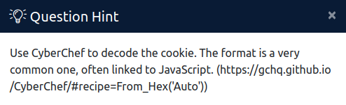

Head to the provided site, and enter the value stored in the authentication cookie into the input area.

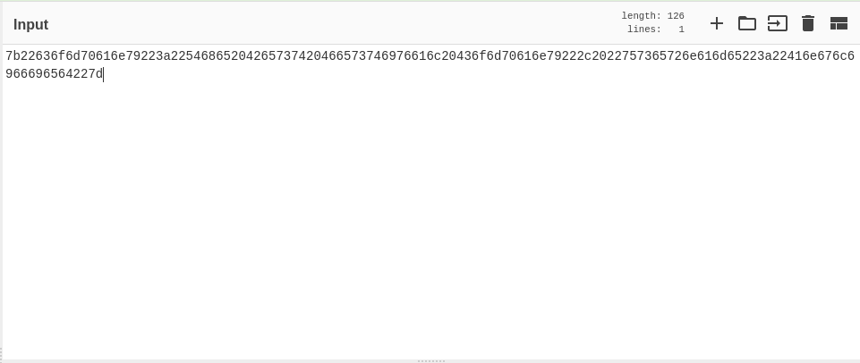

Answer: JSON

Question 4: What is the value of Santa's cookie?

Copy the provided output value, and change the username to “santa” (all in lowercase)



Copy the output and paste it back into the cookie value.

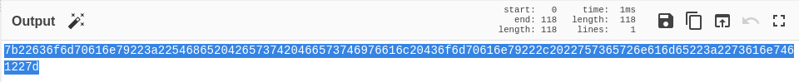

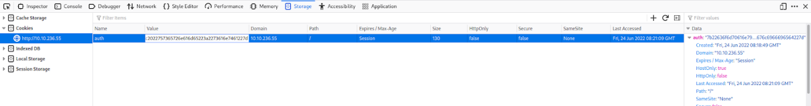

Answer: 7b22636f6d70616e79223a22546865204265737420466573746976616c20436f6d70616e79222c2022757365726e616d65223a2273616e7461227d

Question 5: What is the flag you're given when the line is fully active?

Refresh the page and you can see that you have access to everything.

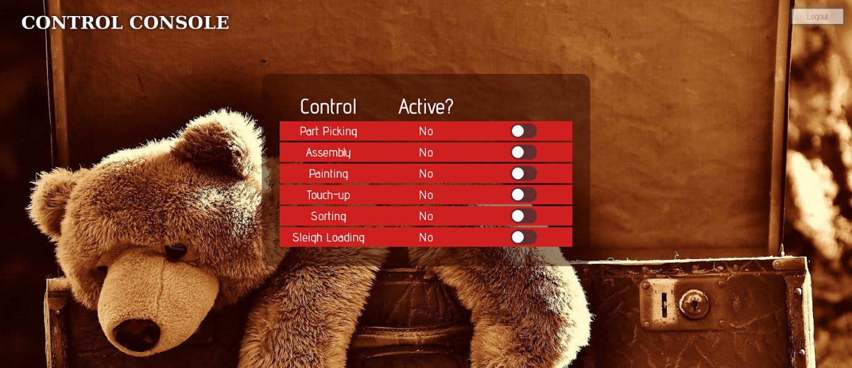

Turn everything on and you can see the flag.

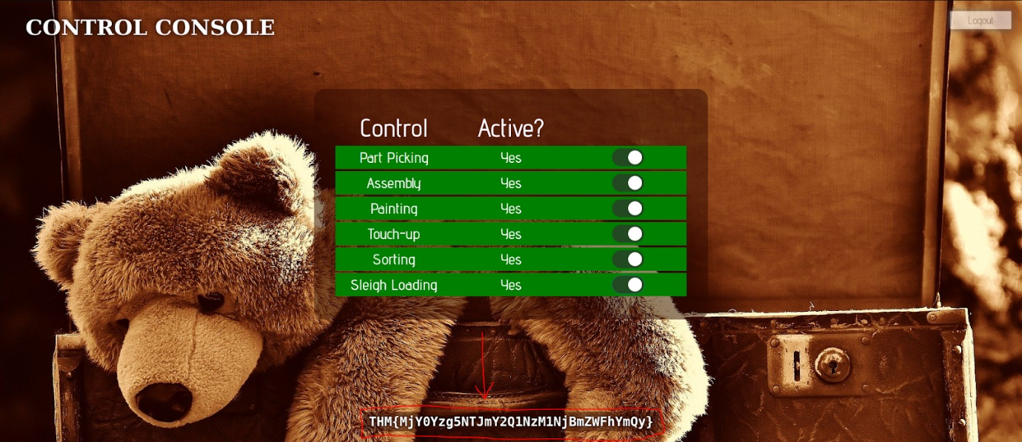

Answer: THM{MjY0Yzg5NTJmY2Q1NzM1NjBmZWFhYmQy}

End of Day 1 report

PSP0201

Week 2

(DAY 2)

Writeup

Group Name: Nvida

Members

|  |  |  |
| --- | --- | --- |
| **ID** | **Name** | **Role** |
| 1211102656 | Dennis Ng Chun Hung | Leader |
| 1211101408 | Ephrem Loo Ee Zhe | Member |
| 1211102910 | Khoo Jen-Au | Member |
| - | - | - |

**Tools Used:**Kali Linux, Firefox

***Question 1***You don’t have access to the upload site.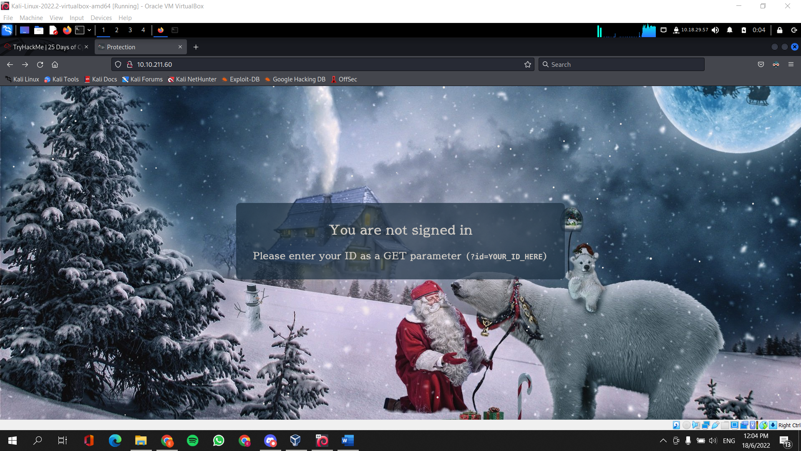

Gain control of the upload site by using the ID number that was assigned to you as a GET parameter.

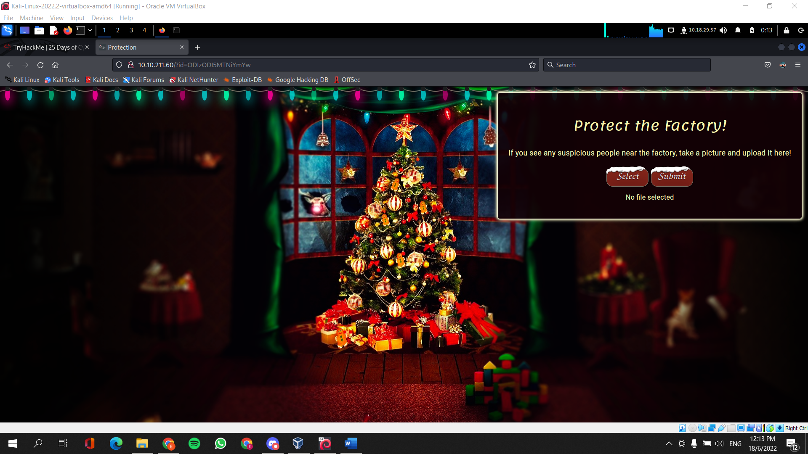

***Question 2***View the page source to determine the what type of file is accepted by the site.

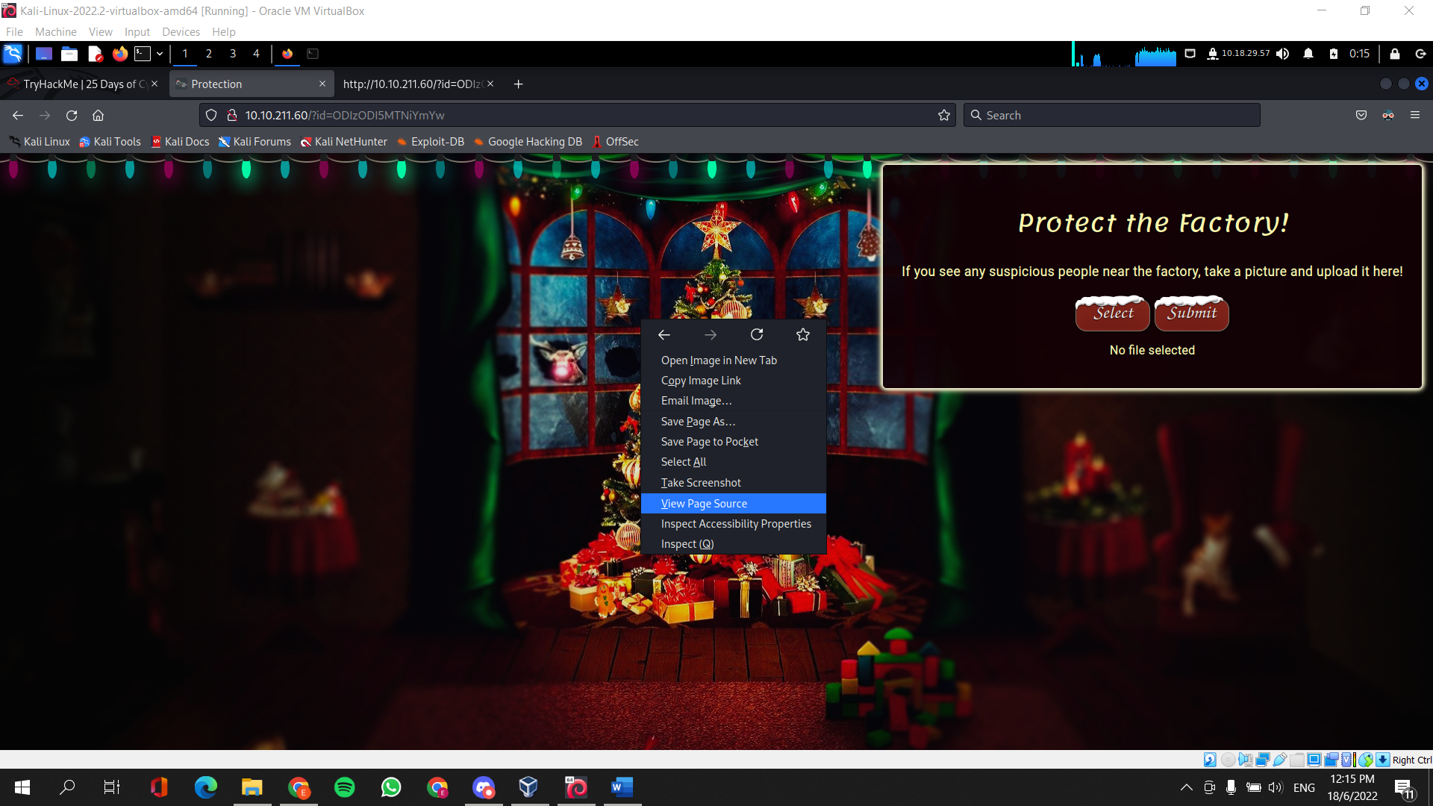

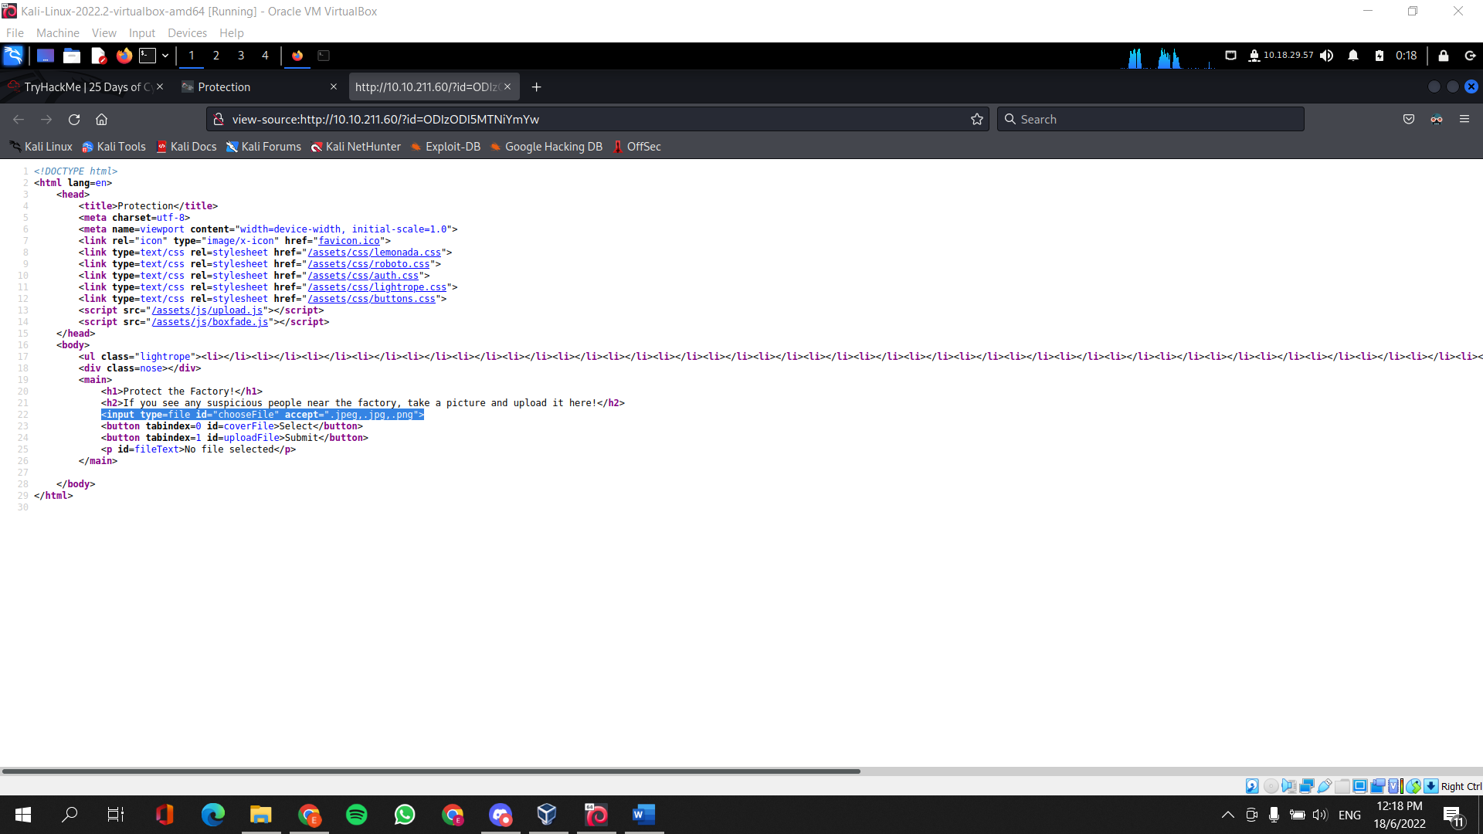

***Question 3***Guess the subdirectory by using common ones like /uploads , /resources , /images and /media to find where the files are stored.

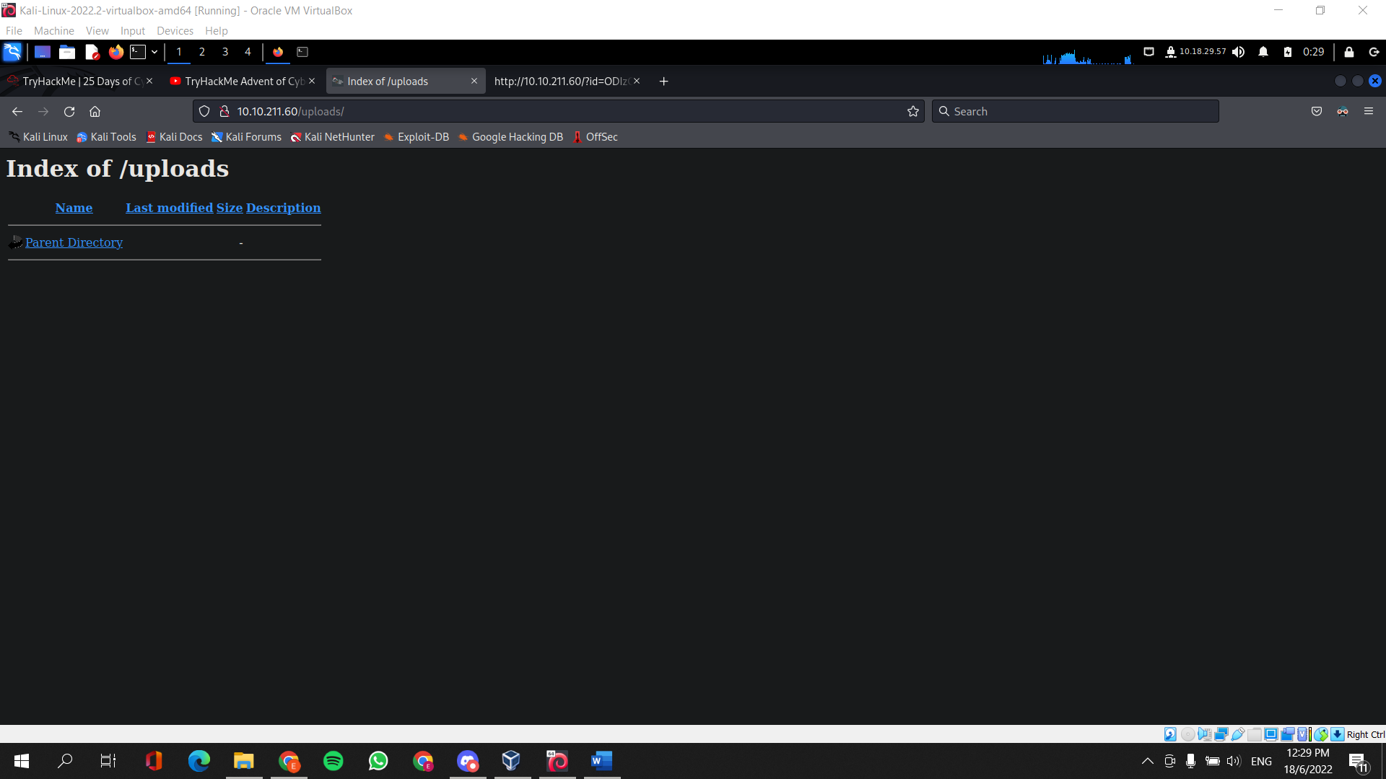

***Question 4***Copy the given webshell into the terminal (cp /usr/share/webshells/php/php-reverse-shell.php .)

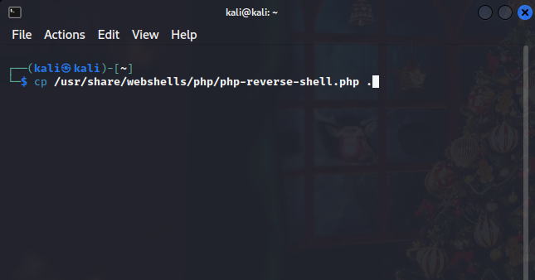

Edit the file with your prefered choice of text editor.   
Locate **$ip** and **$port (both are marked with //CHANGE THIS)**For **$ip**, set the IP to your TryHackMe IP Address if you’re using the AttackBox. If you’re using a VM or VBOX with an openvpn use that IP Address (*keep the double-quotes).  
For **$port**, set it to 443.  
Save the file and exit.

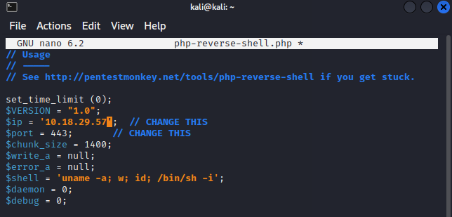

Rename the file with the file exntension of .jpeg , .jpg, or .png (in between php-reverse-shell and .php) eg. php-reverse-shell.jpeg.php . This is important because the file extension accepted by the website are images only.

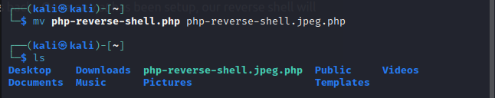

Upload the reverse shell onto the website

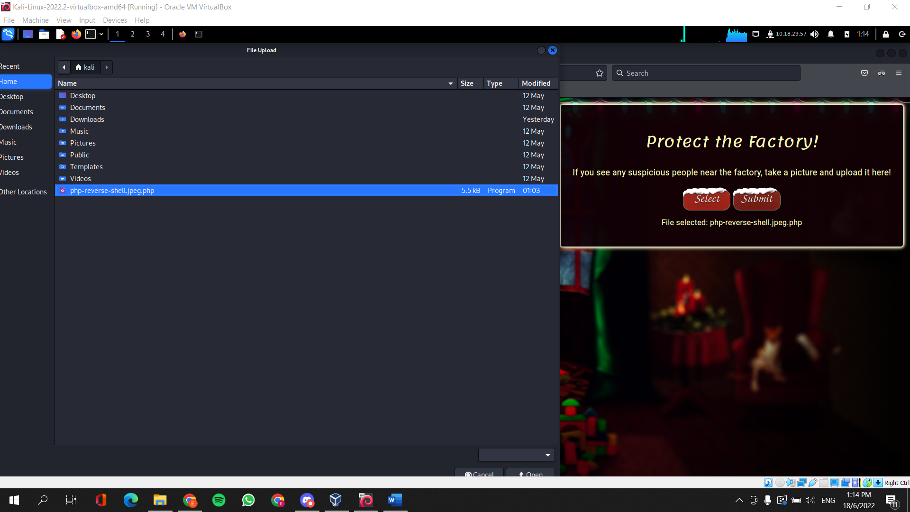

Run the netcat listener, activate the command and catch it in the netcat listener.

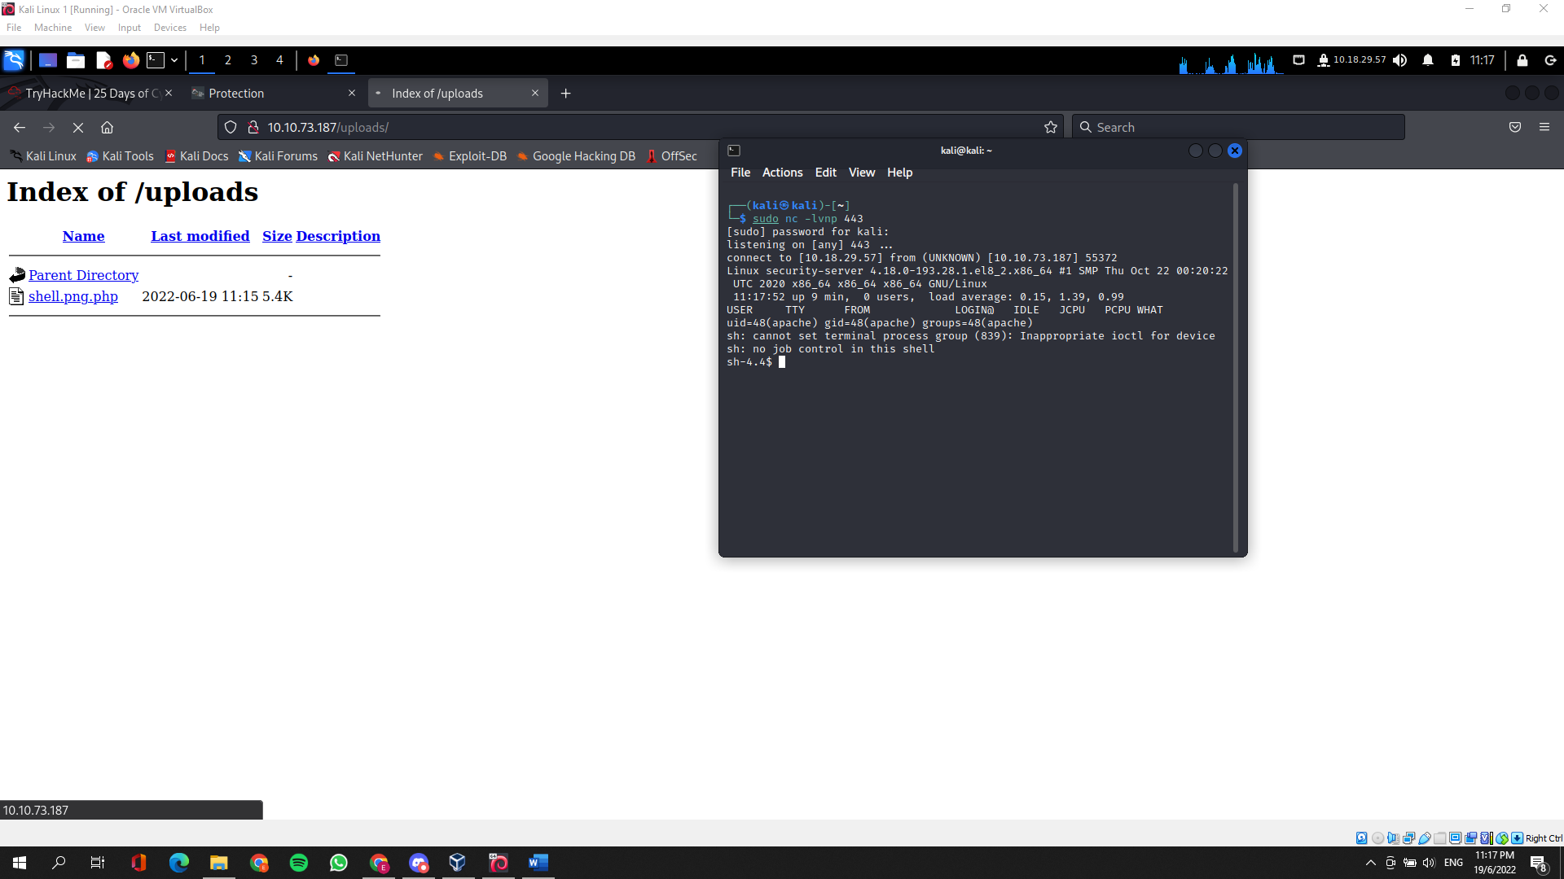

***Question 5***

Read the file to find the flag   
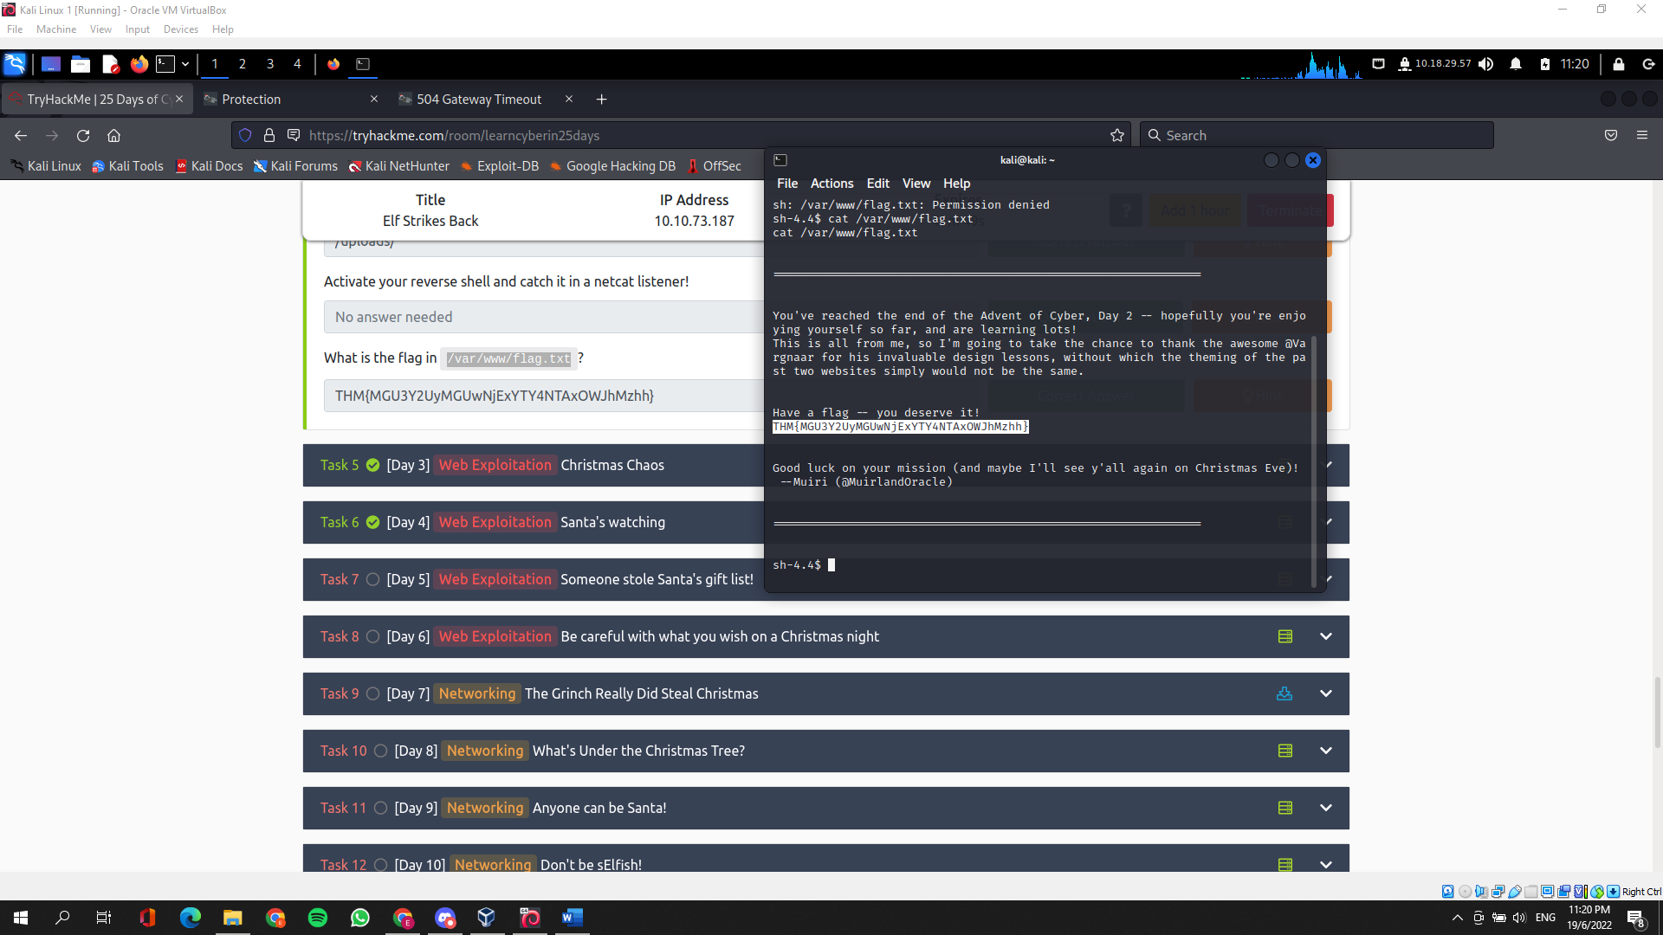

***Thought Process/Methodology:***

Having to access the targeted machine, we were shown that we aren’t signed in. Having the ID number provided, we used it to gain access to the upload section of the site. Knowing that there is a upload section of the web, we can assume that there is a subdirectory where all the uploaded files go, therefore we can bruteforce with common subdirectories such as “/uploads”. Once that is done, we need to upload our malicious script in the upload section of the web, but before that, we need to configure the our malicious script with the right IP and PORT. Once successfully configuring our malicios script, we need to try uploading some innocent files to check whether it accepts the type of file we have uploaded. If it doesn’t accept the file, we need to view what file extensions does the web accept, we can do that by viewing the source page. With that knowledge, we can now change our malicious script file extension to the correct one with a double-barrelled extension. Once uploaded, run the netcat listener and activate the malicious script on the upload subdirectory. With that all done, we are now able to read the files for the flag.

End of Day 2 report

PSP0201

Week 2

(DAY 3)

Writeup

Group Name: Nvida

Members

|  |  |  |
| --- | --- | --- |
| **ID** | **Name** | **Role** |
| 1211102656 | Dennis Ng Chun Hung | Leader |
| 1211101408 | Ephrem Loo Ee Zhe | Member |
| 1211102910 | Khoo Jen-Au | Member |
| - | - | - |

**Tools Used:**Kali Linux, Firefox, Burpsuite

Step 1

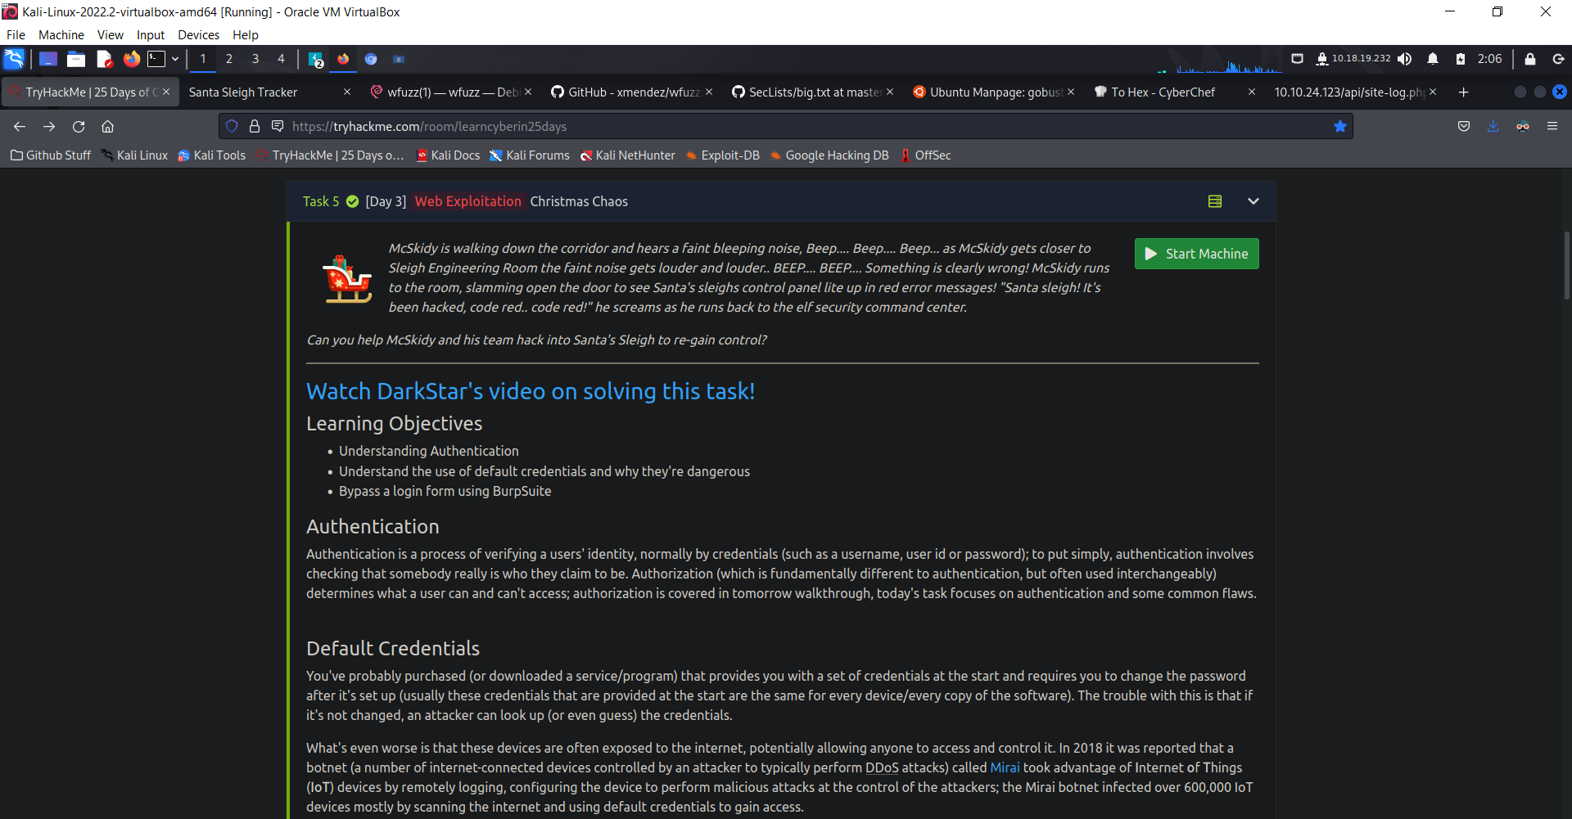

First, enter to THM Day 3 and start the machine in order to get the IP address and start our Day 3 exercise. Once after we got our Ip address from the machine, we can start our Day 3 right away. After we got our Ip address, input the Ip on the search bar and start searching for the website.

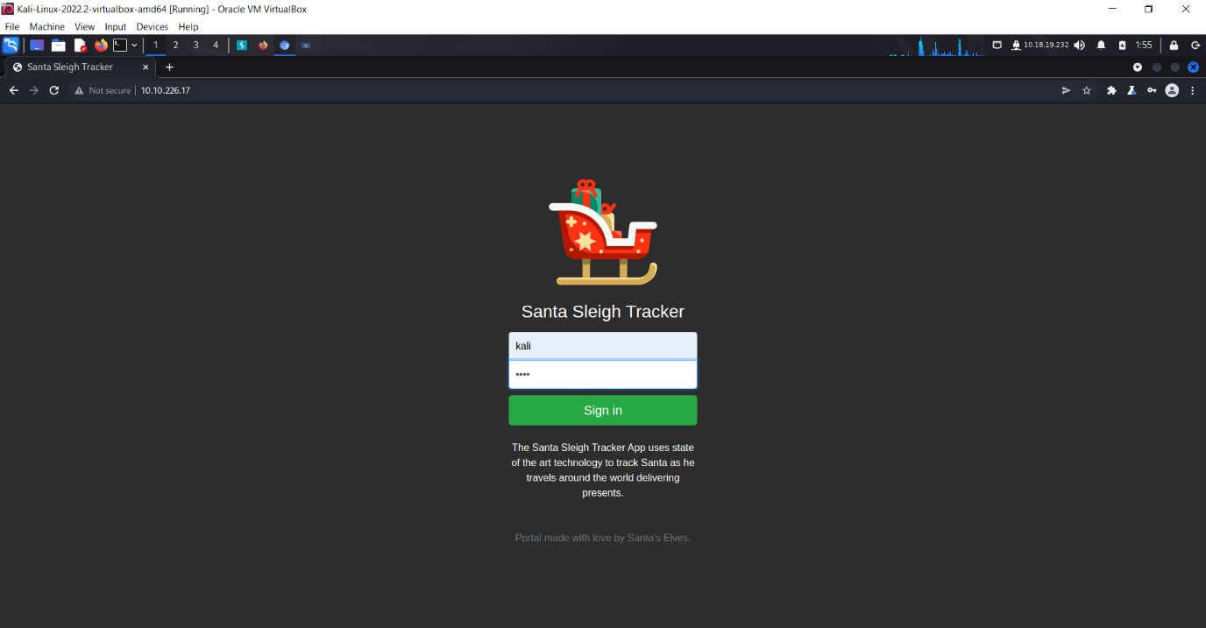

After we search for our Ip is the search bar, we will get the website for our Day 3 exercise. As shown in the picture above, we are shown with a login bar under Santa Sleigh Tracker, after keying in username and password Kali. We are shown a your password is incorrect notification.

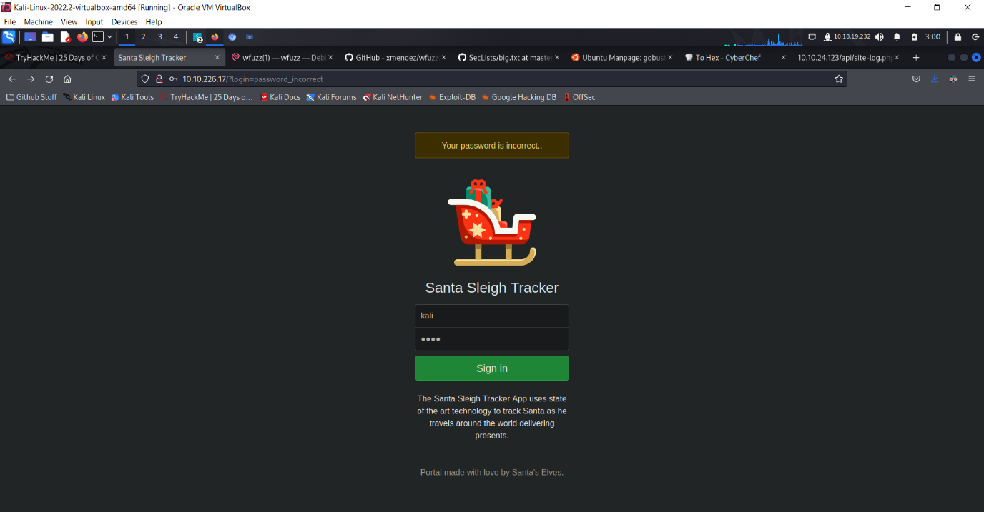So what we need to do now would be start up our BurpSuite and intercept the website.

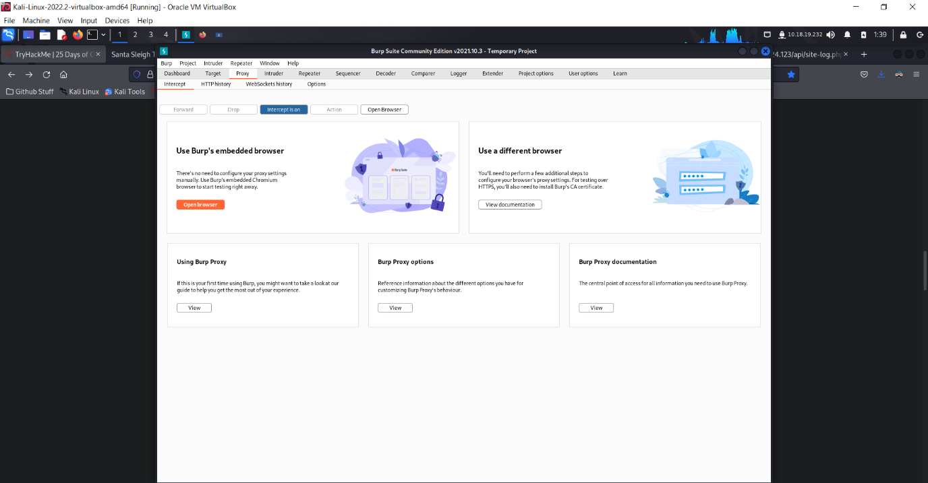

After lauching our BurpSuite, you will have to first turn intercept on and click on the orange Open browser button. This will lead you to their browser page. And after opening their browser page, put in the Ip address provided by the machine to open the website.

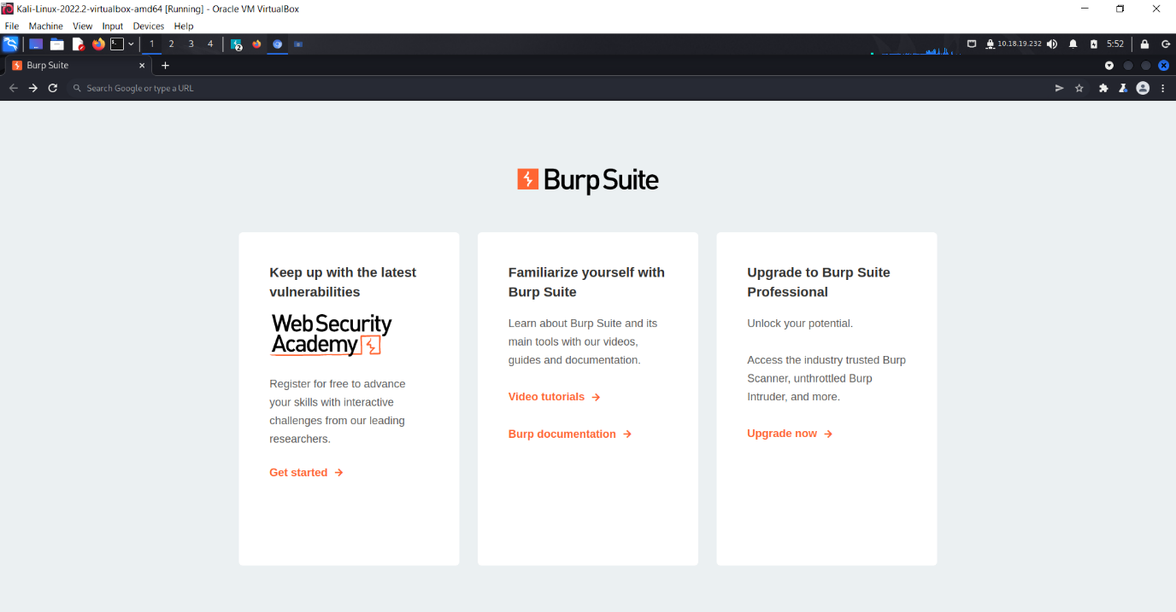

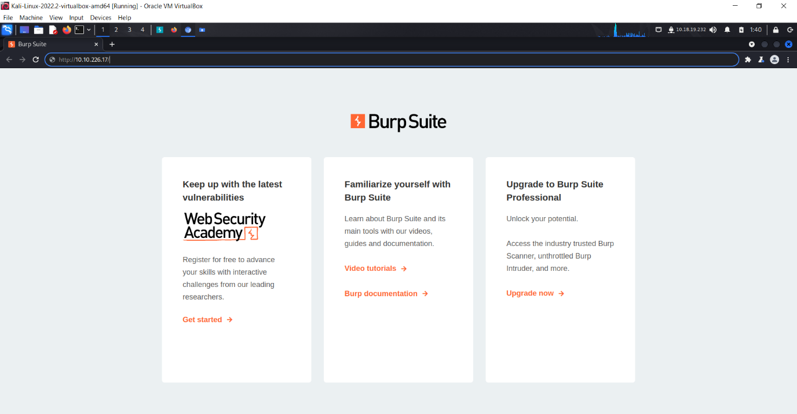

After putting the Ip address into the search bar in BurpSuite, it will lead you to this page as shown below. Make sure the username and the password you tried to log in with is display in the command box, if it’s not there or have different words in the command box, then it is wrong.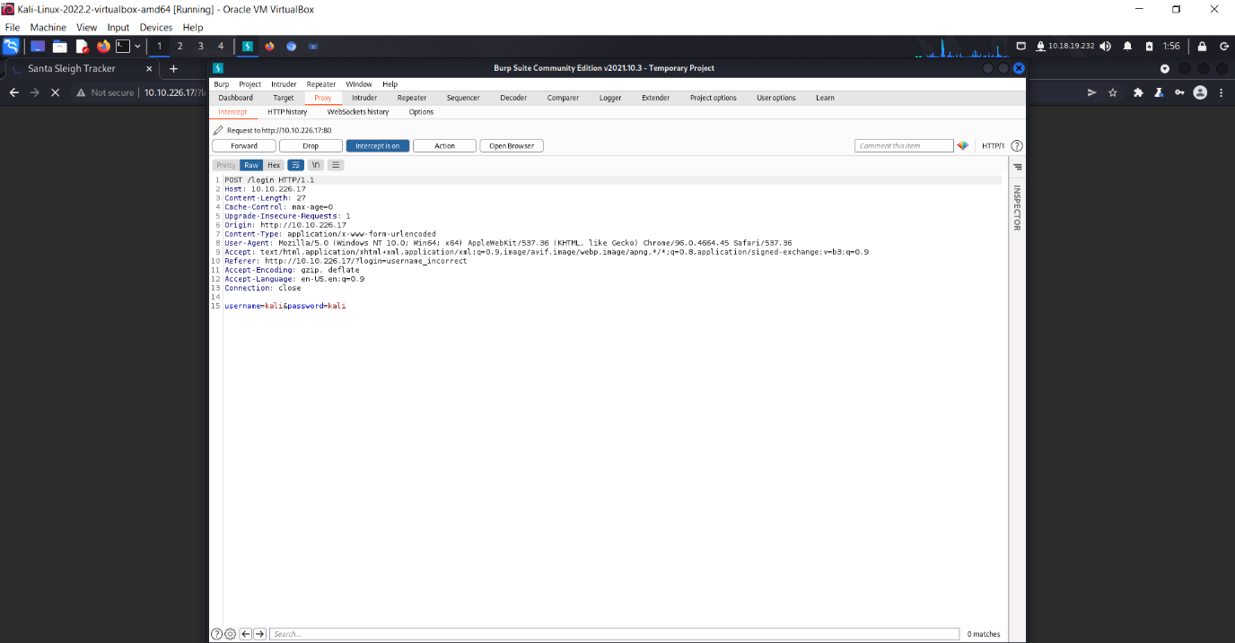

Next, after getting the correct stuff as shown in the picture above, right click the page and click send to intruder.

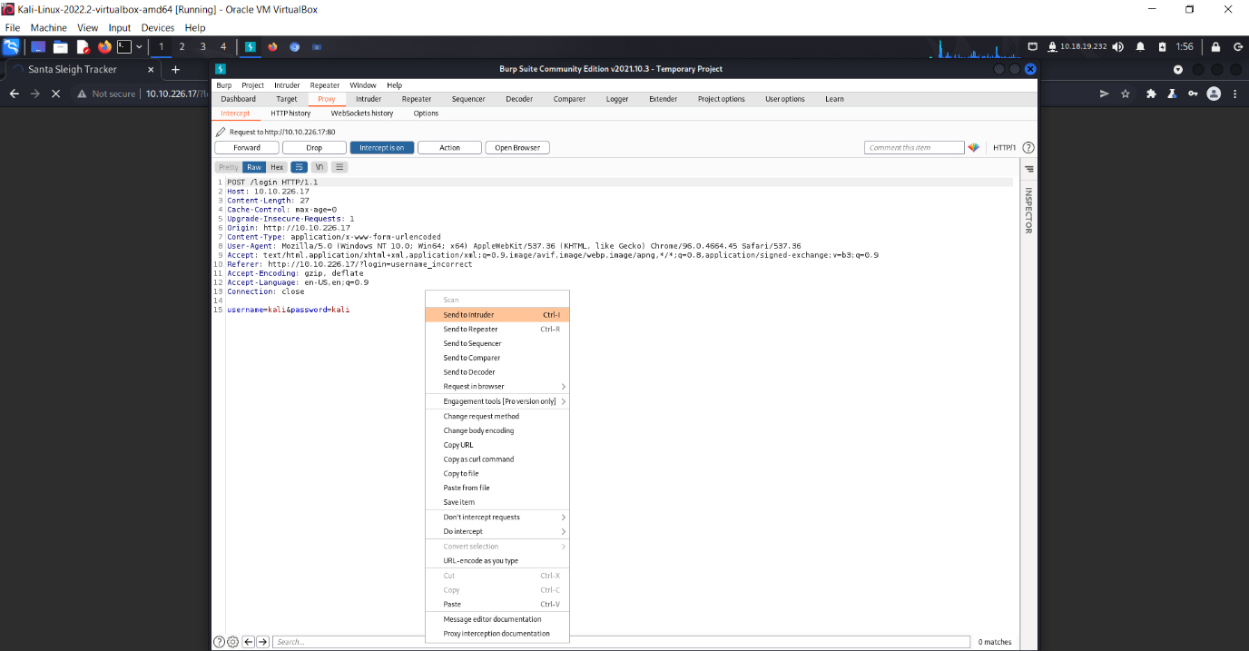

After sending it to intruder, your next step would be going to the button intruder and click it. After entering intruder page, find the button bar ‘Position’ and click it. You will then see as shown in the picture below.

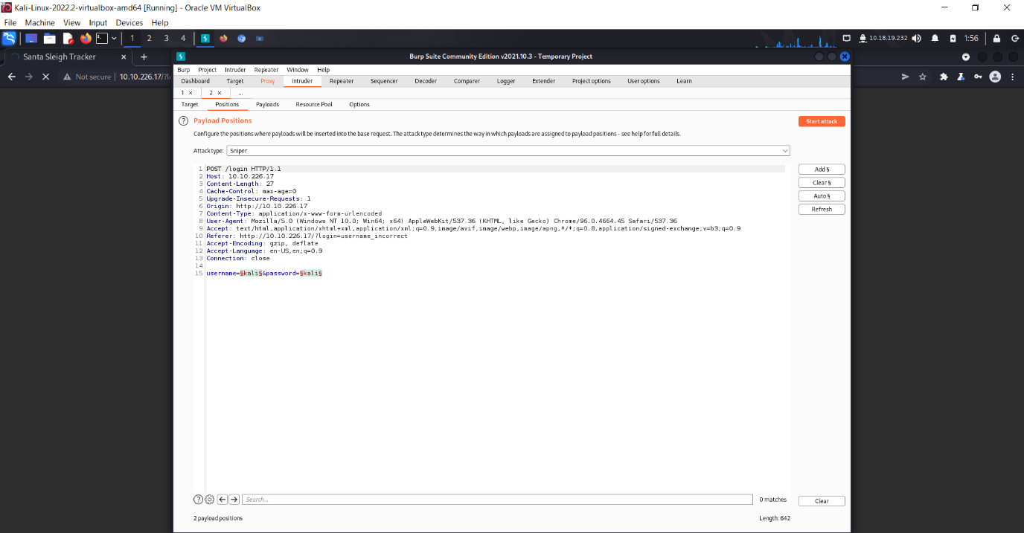

Next, click on the Sniper bar and change it to Cluster bomb. Sniper for this part would be slow attack but low percentage of getting detected, while cluster bomb would be brute forcing our way in, it’s fast and effective, but higher percentage of getting caught.

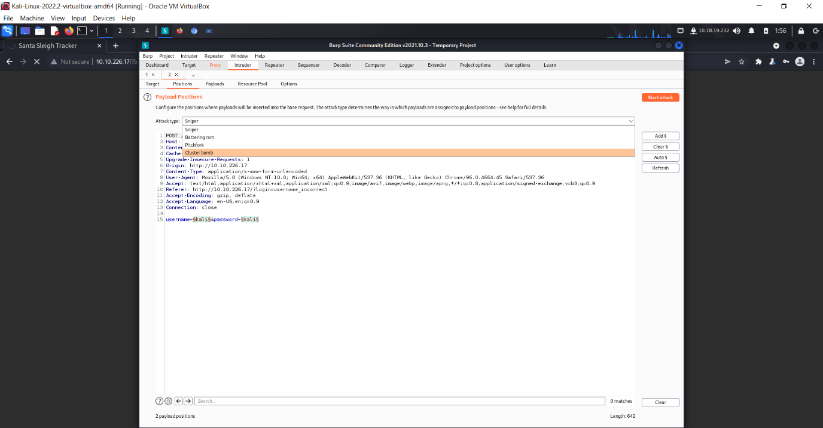

After changing our hacking method, it’s still not ready to go yet, as we have to add some stuff inside of payload.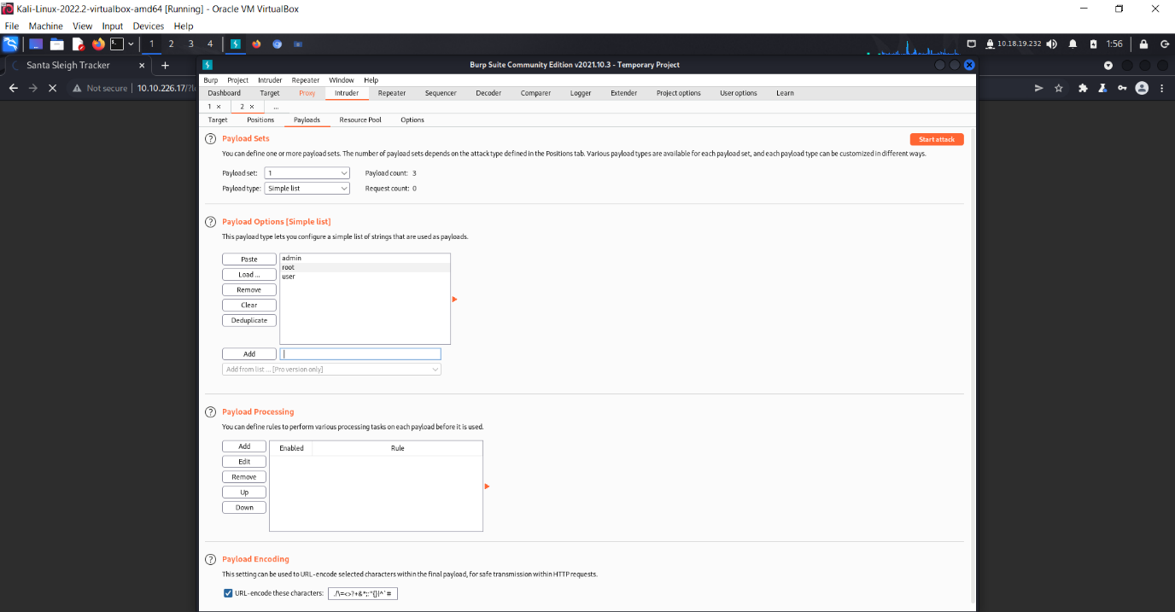

Inside of payload, we have to add in 3 characters, and that is admin, root and user. Then after it’s done, switch the payload set on top to payload set number 2 and also type in 3 new characters and that is password, admin and 12345.

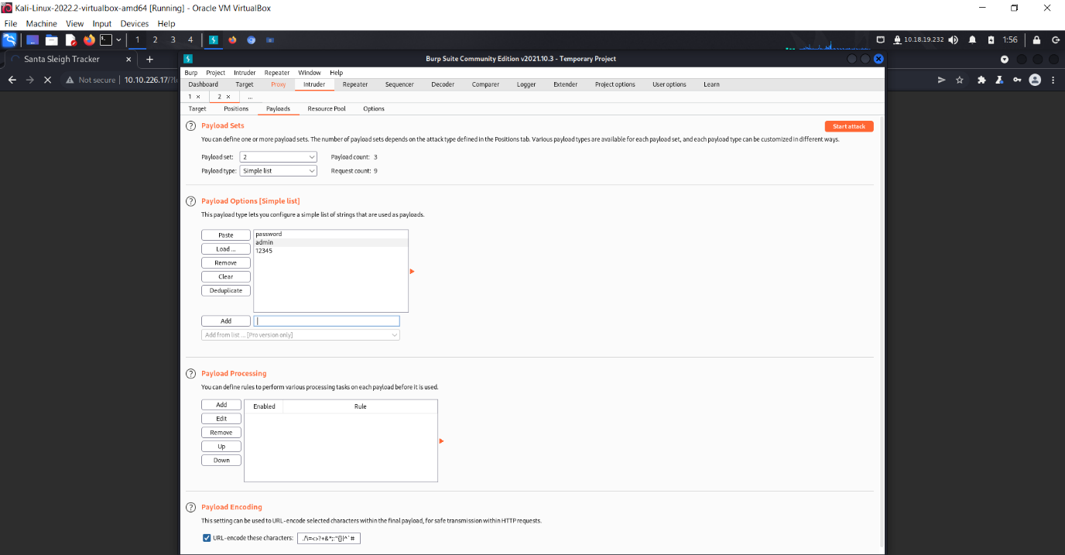

Once all characters are done inputting, you may now start the attack now!

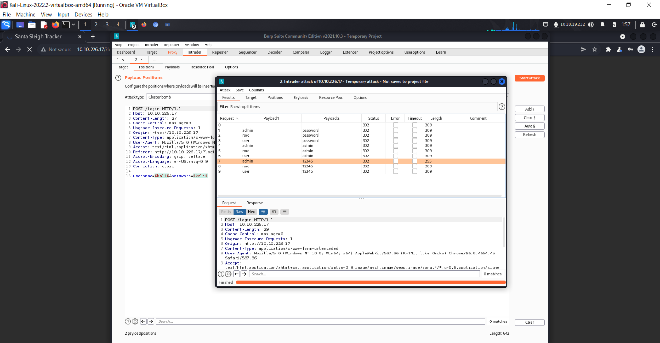

Now you have started the attack, you might need to wait for a while for it to list out all the possible combination for both the username and password. Once it’s done, you will see the pop up shown in the picture above and you may start searching for the one that have different values than the rest, and that would be the key to enter the website.

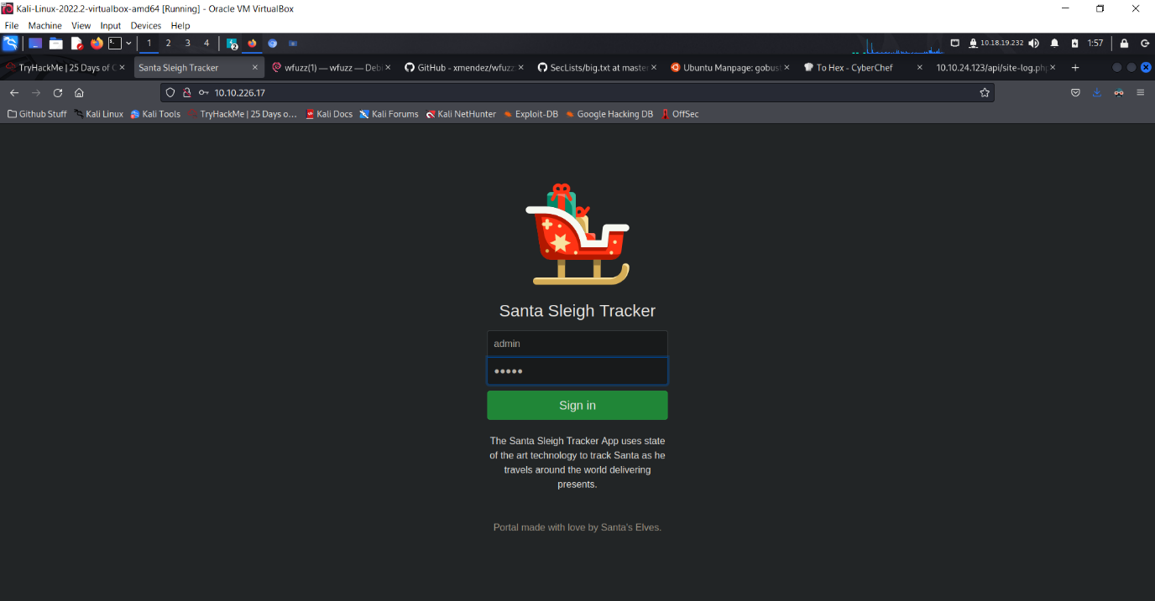

After you’re all done with the stuff above, go back to the website page where you will need to log in and type in the answer you have found in BurpSuite.

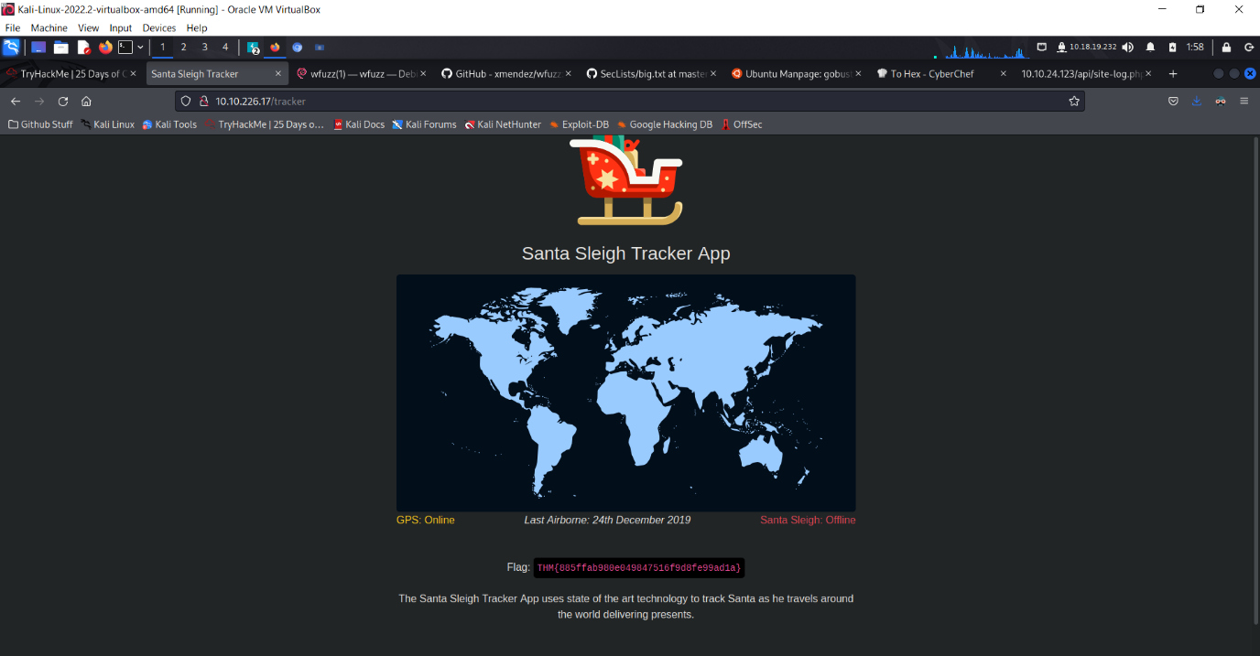And there you have it, after putting the answer we found in BurpSuite, we now have access into the web page and found the answer for our Day 3 last question.

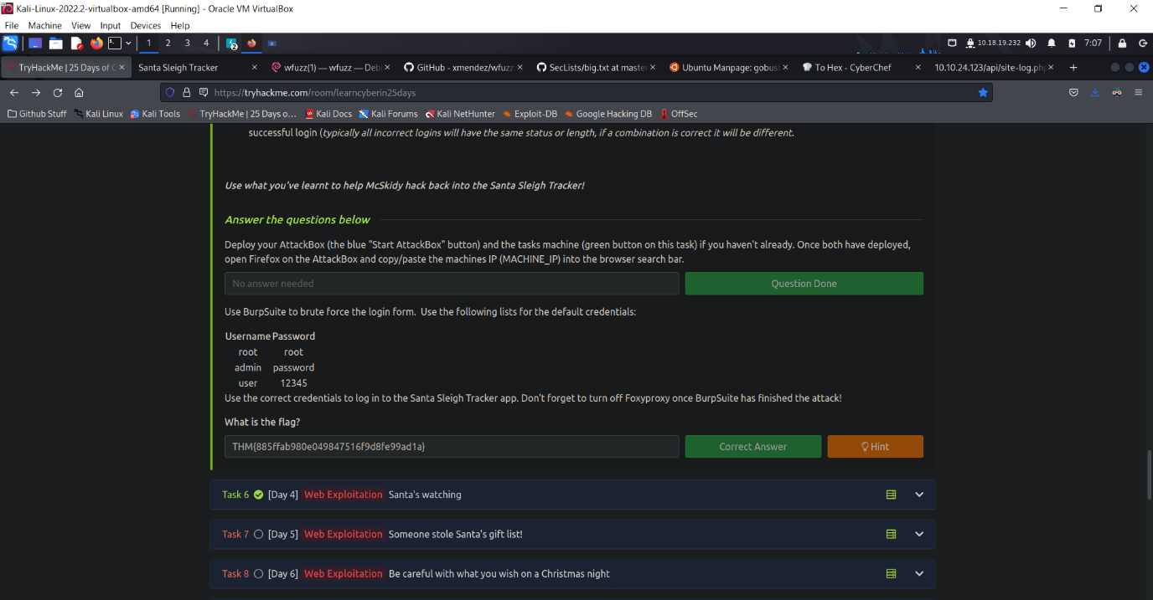

End of Day 3 report

PSP0201

Week 2

(DAY 4)

Writeup

Group Name: Nvida

Members

|  |  |  |
| --- | --- | --- |
| **ID** | **Name** | **Role** |
| 1211102656 | Dennis Ng Chun Hung | Leader |
| 1211101408 | Ephrem Loo Ee Zhe | Member |
| 1211102910 | Khoo Jen-Au | Member |
| - | - | - |

**Tools Used:**Kali Linux, Firefox, Gobuster, Wfuzz

Step 1

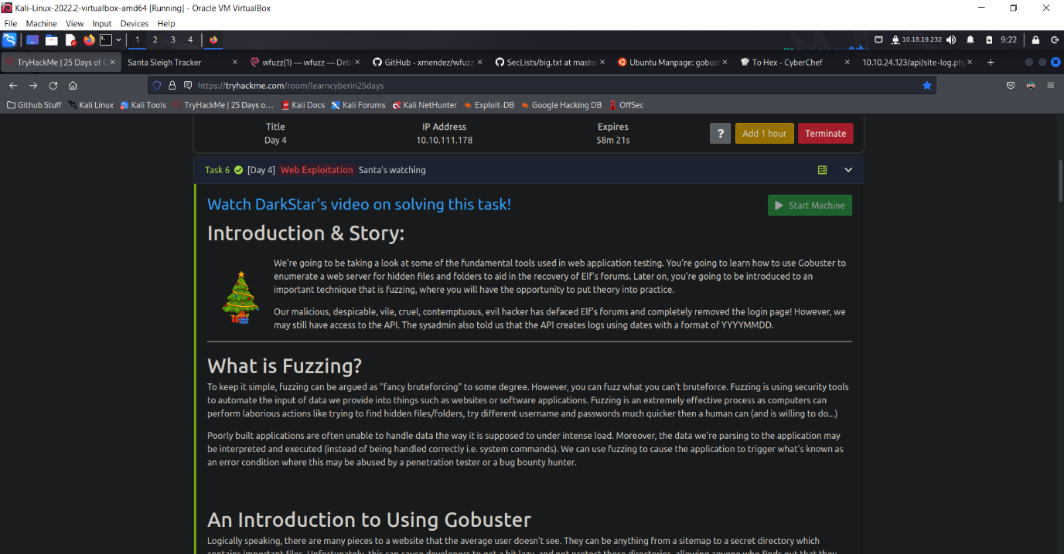First, let us start our machine and get the Ip address for Day 4. After we received the Ip for Day 4, type the Ip address into the search bar to enter the website.

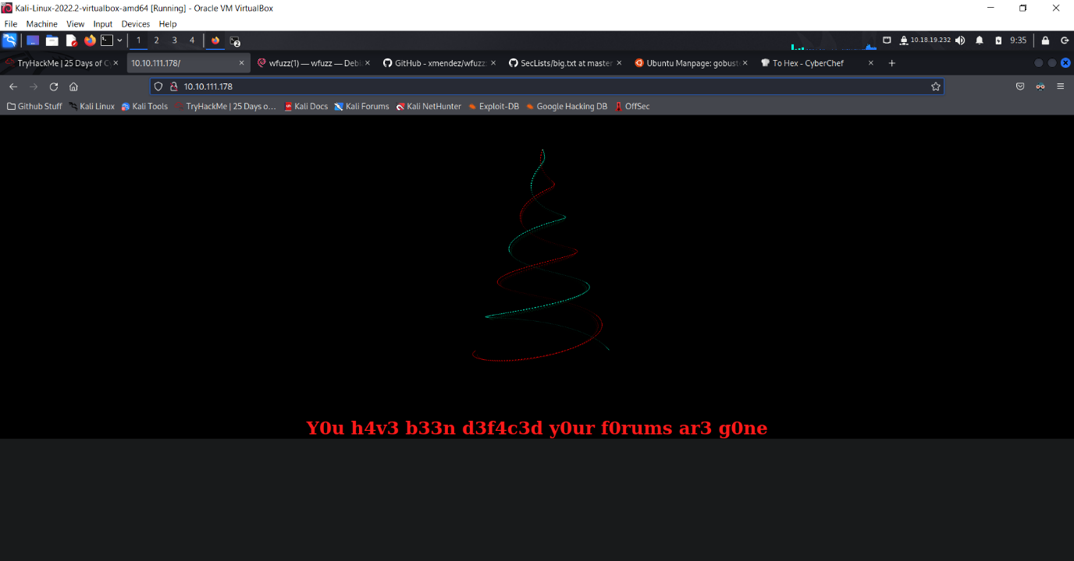

After searching for the Ip address, we have come to the web page that says Y0u h4v3 b33n d3f4c3d y0our f0rums ar3 g0ne, meaning there won’t be any log in function for us to enter and find any files that may contain inside.

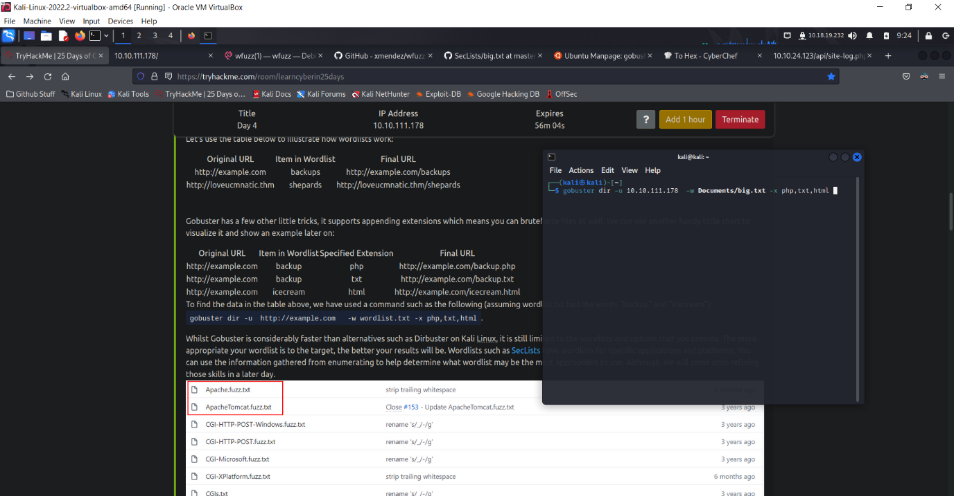

In order for us to find any important files that may contain inside, we can use Gobuster to help us brute force our way in. First, we need to use the command gobuster, then dir, which means directory for short, then enter the command -u, which means the url that we’re trying to bust it, then the command -w, which means the wordlist string path of the wordlist file, and lastly the command -x, which is the example of the file format you want to narrow down the search for files. After we have input all the necessary commands, it’s time for us to start the search now.

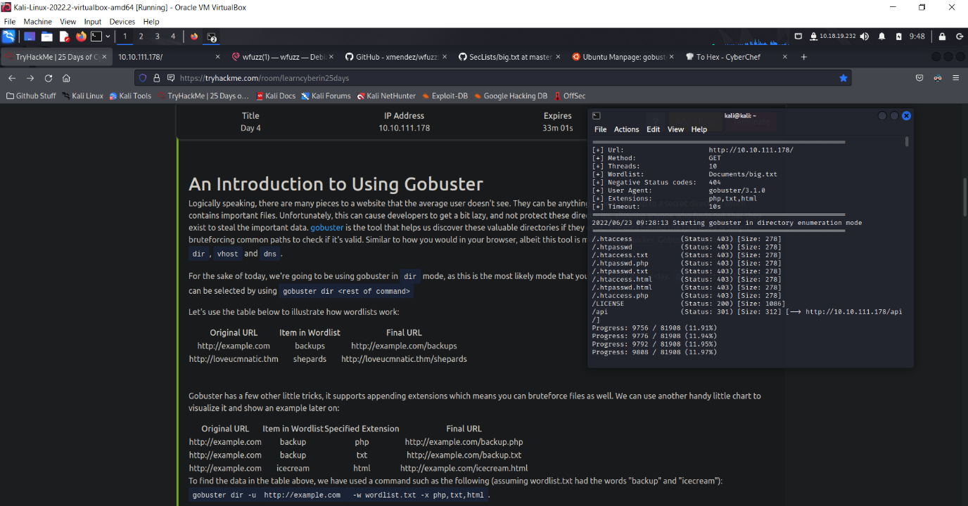

After waiting for a while, we found 2 possible file directory, /LICENSE and /api. Let’s first try and see what’s inside of /LICENSE. By putting the word /LICENSE at the back of the Ip address, we can find where are the files located.

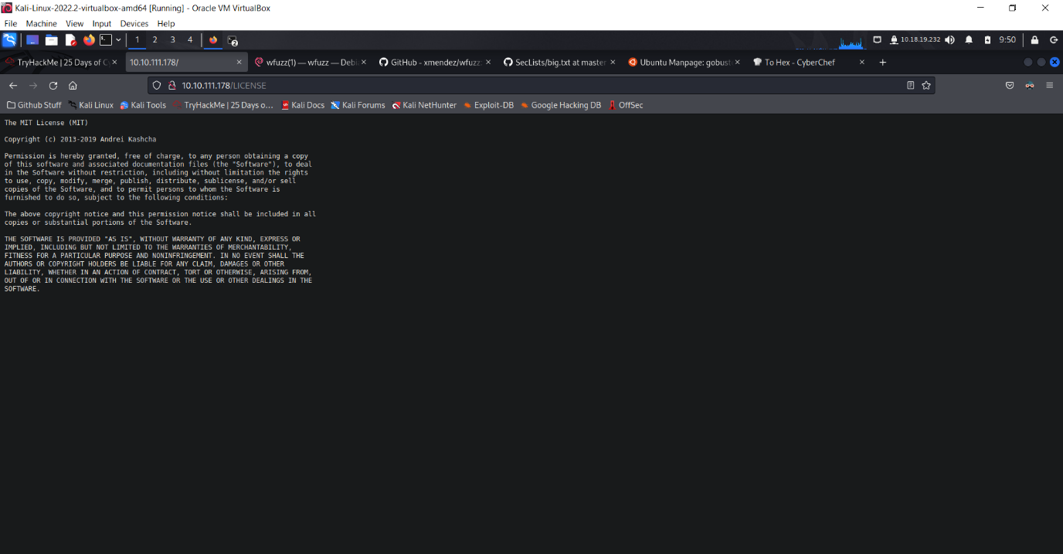As shown above, this is the /LICENSE page where it shows all of it’s License stuff for the web page. Now what left would be /api. Let’s try searching for /api now.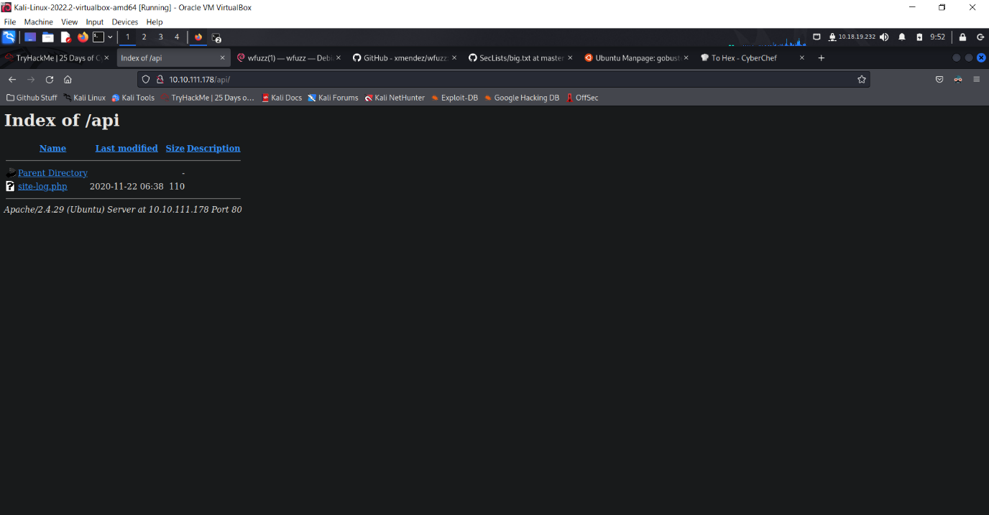As you can see, we found something inside of /api. There is a site-log.php located inside of api.Let’s click into it.

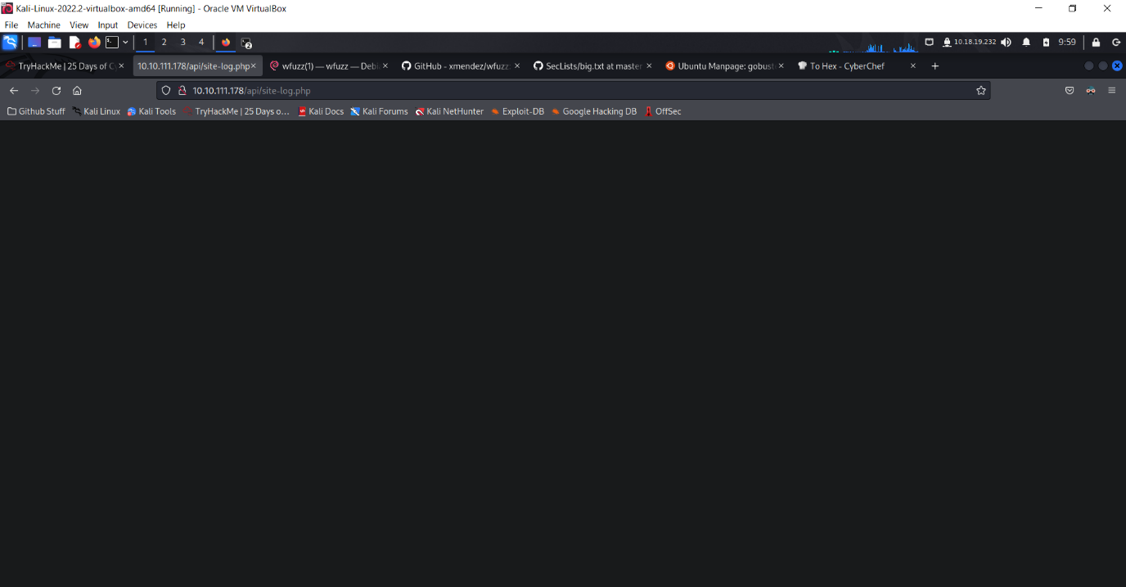

It seems upon interaction, there’s nothing inside for us to get the information for our question in THM, do not fret as there is another way to find the things we want to find.

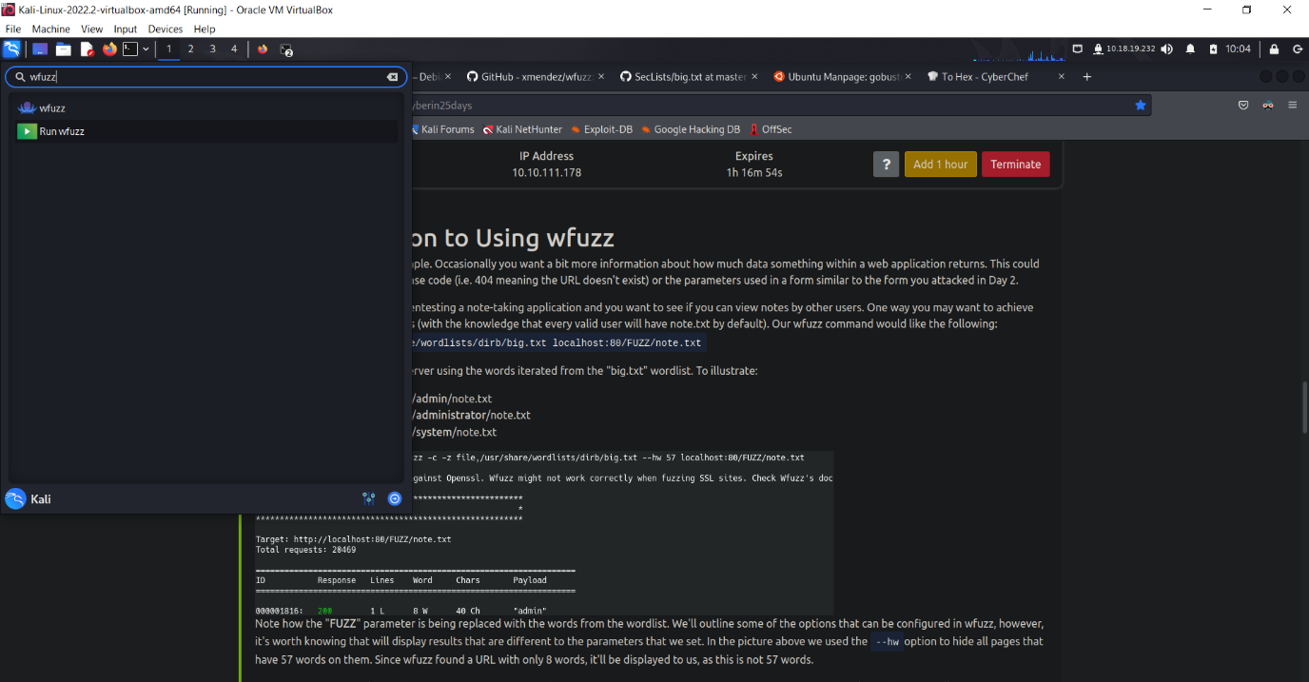

Firstly, we can just use the wfuzz function by entering wfuzz in Kali’s search function to quickly navigate to wfuzz command prompt.

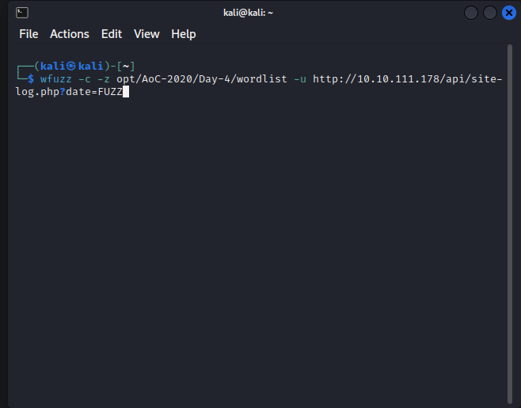

Or, we could just type out the command wfuzz in any of the terminal in Kali to just straight away use it. So after we know where to find wfuzz, now it’s time for us to use the command and why we need to use it. The premise behind wfuzz is actually simple. Occasionally you want a bit more information about how much data something within a web application returns. This could be anything from a file, a response code or even a parameter. Now on the commands, for -c, it’s to change some of the output colours to allow us to see commands clearer, next would be the -z command. The – z command is to scan for files inside the directory we specify in, so meaning if we put -z file, opt/AoC-2020/Day-4/wordlist , it will scan for the information inside of that specify wordlist. Next one would be -u, which is to specify that <http://10.10.111.178/api/site-log.php> is the url in this terminal. And lastly, the symbol ? and DATE=FUZZ. So for the symbol ?, it means query, and for FUZZ, it’s just one of the wfuzz function that helps us to fill up the empty space that we currently don’t know and wfuzz helps us to find the file format for it by using the information inside of the wordlist file, as right now we don’t know what’s the DATE for this web page, so we just put ?(query) DATE=FUZZ( it’s for wfuzz to fill it in for us when it found a suitable txt for it inside of the wordlist)  
But for my case here, it’s inside of Download folder, so the command is different for everyone as everyone puts their wordlist in different location as their liking. The picture below is my directory for the wordlist and the command I used.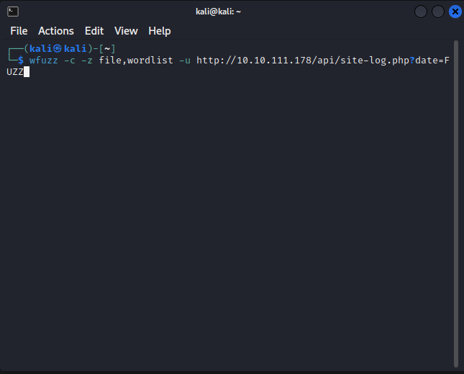

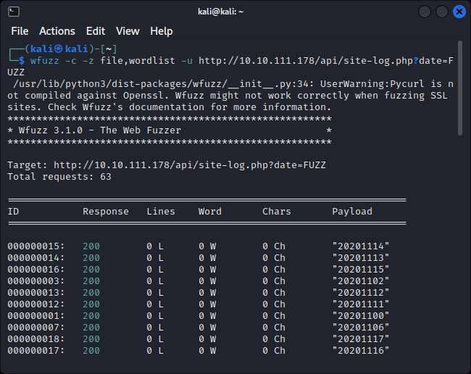After the command is done and press enter, it will show all the possible ID’s and what we need to do now is to find the only one that is different from others.

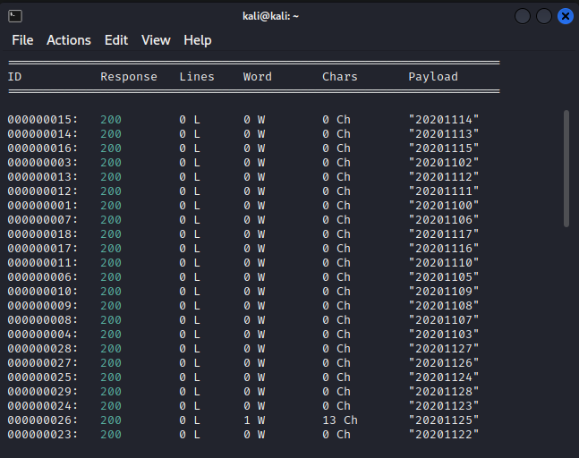So after searching for a while, we finally found that one ID that has different Characters from the others. Now copy the Payload numbers from that ID and paste it at the very back of the website Ip. Like this <http://10.10.111.178/api/site-log.php?date=20201125>, oh and a headsup, notice that I wrote small letter date instead of big letter DATE is because the big letter DATE is just to let you see clearly and have a better understanding of it, but in commands or in any url, the word DATE must be in lower letter, as they are programmed to only accept lower letter to not confuse their programming. So if you put big letter DATE instead of small letter date, the command inside of the terminal box and in the website search page will not function for you and thus you must always remember to put only lower letters for in any of the command boxes.

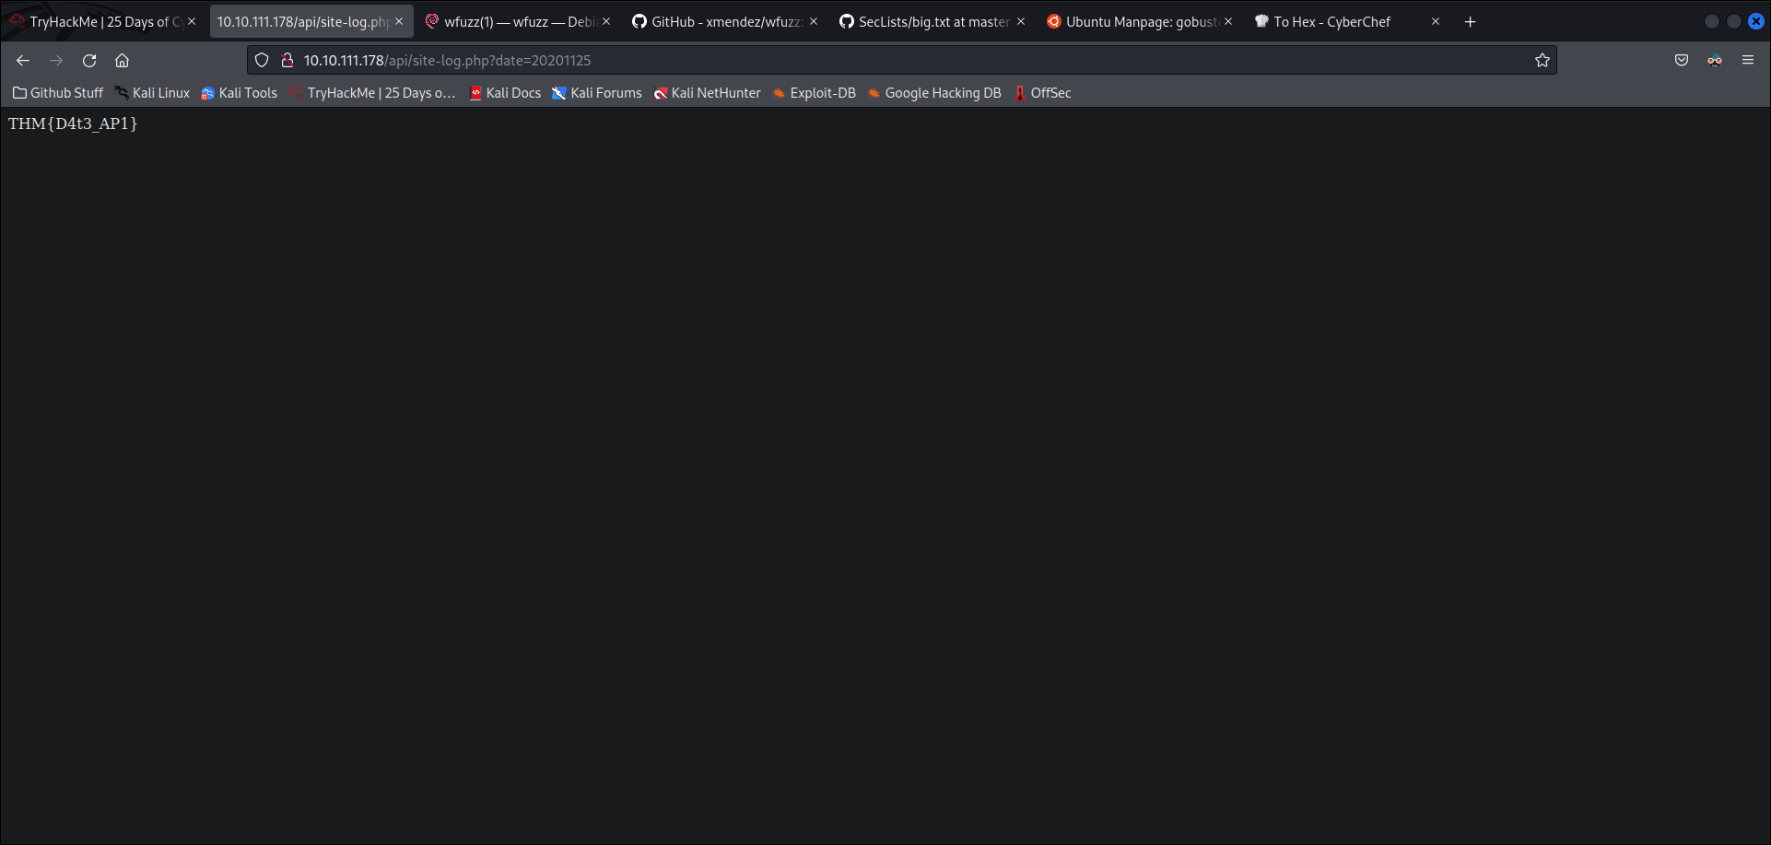After we have done everything and input the final numbers at the very back of our website Ip, we will see a few characters in the empty web page, and those characters would be the answer for our final THM question.

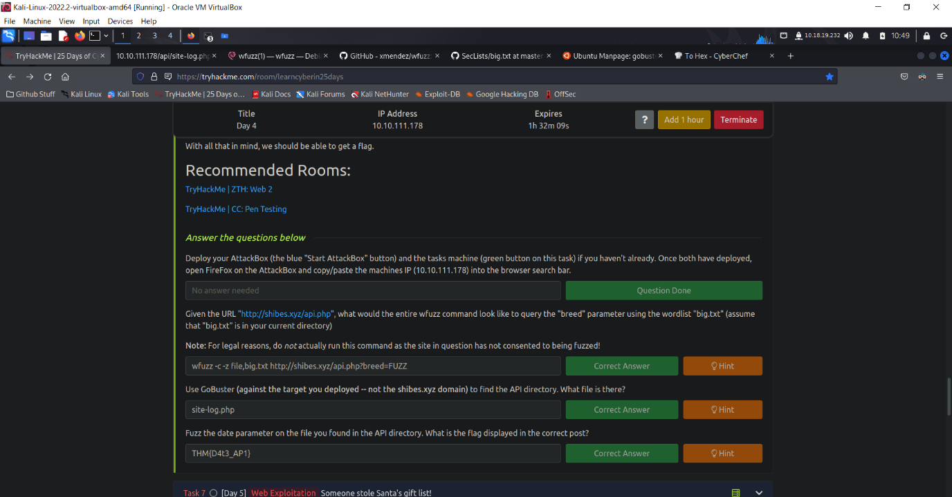

End of Day 4 report

PSP0201

Week 2

(DAY 5)

Writeup

Group Name: Nvida

Members

|  |  |  |
| --- | --- | --- |
| **ID** | **Name** | **Role** |
| 1211102656 | Dennis Ng Chun Hung | Leader |
| 1211101408 | Ephrem Loo Ee Zhe | Member |
| 1211102910 | Khoo Jen-Au | Member |
| - | - | - |

**Tools Used:**Kali Linux, Firefox, Burpsuite

Step 1

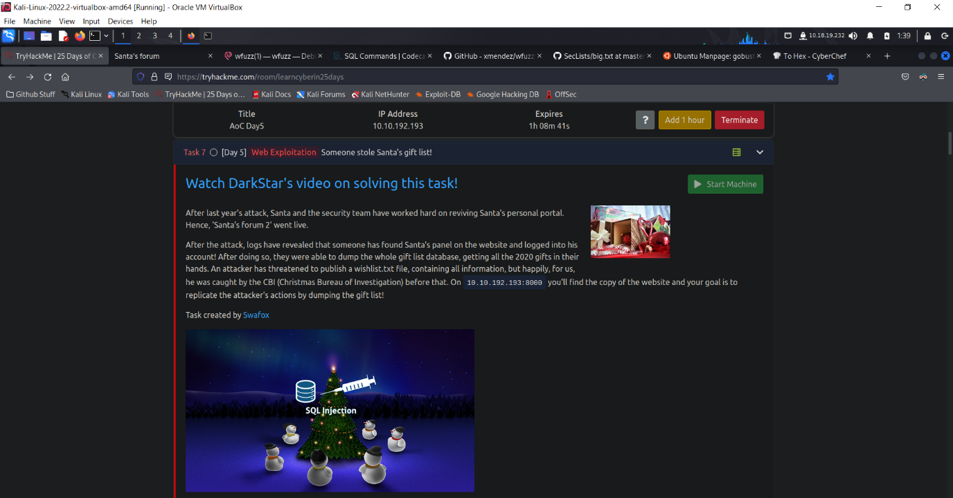 First, let us start our machine and get the Ip address for Day 5. After we received the Ip for Day 5, type the Ip address into the search bar to enter the website.

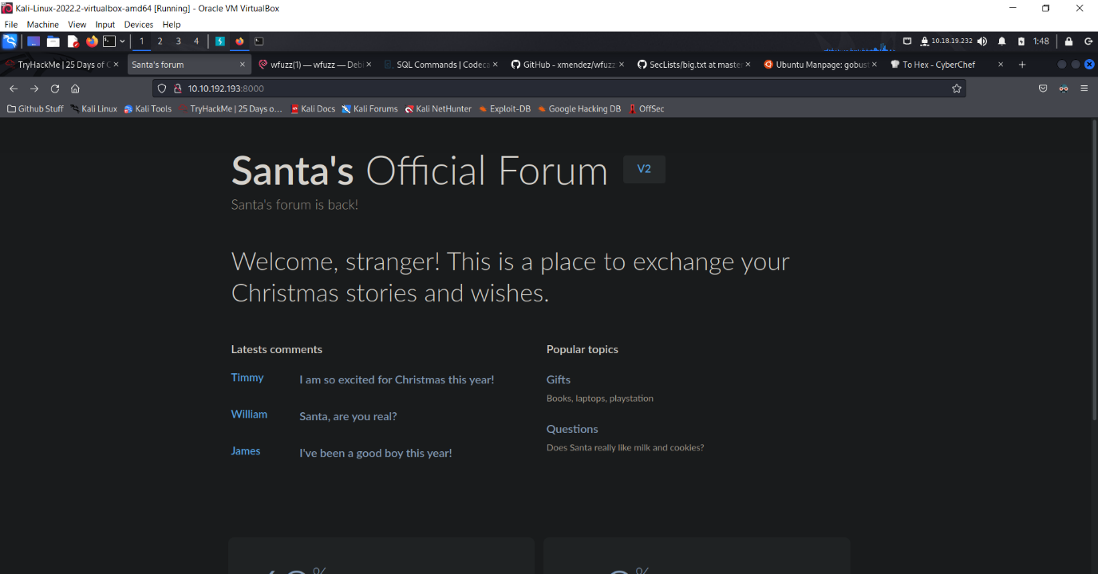After searching for Ip address and enter the website, you will see the website page where it says ‘Santa’s Official Forum’. Now we’re on the right track, let’s proceed to question 1.

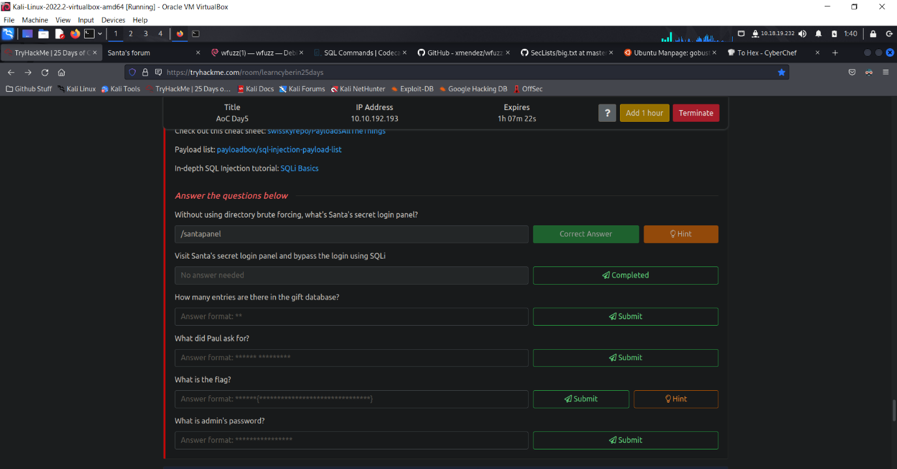In the first question, it tells us without using any directory brute forcing, find santa secret login panel, and we found out in the hint that it’s actually just /santapanel. So now we have the santa’s secret login panel, we can now search for it in the search bar with the provided Ip address.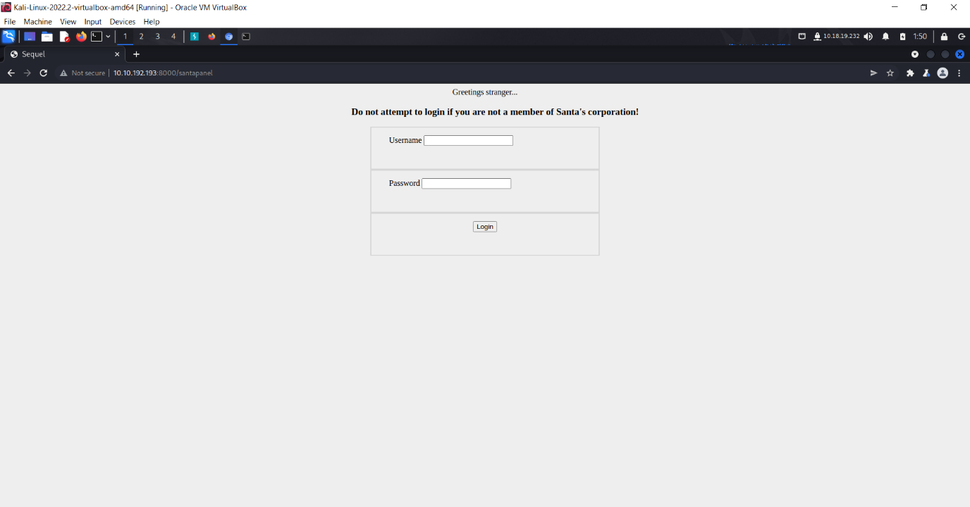

Right now we’re in Santa’s secret login panel, let’s try and trick the system by using SQLi attack.

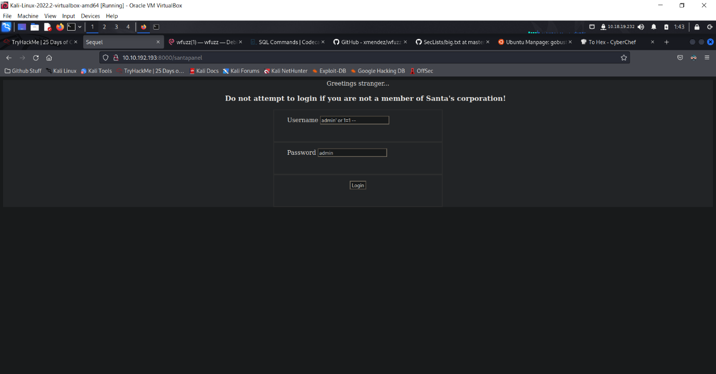As you can see here, we typed in admin’ or 1=1 for username and admin for password. First of all, before we proceed on, let’s talk about the symbol ‘. The symbol ‘ is to break the SQL query and 1=1 is the SQL code. But what does 1=1 really means is that it means true, as 1=1 is always true, and the symbol – means fixing the query and making the the SQL part of it.

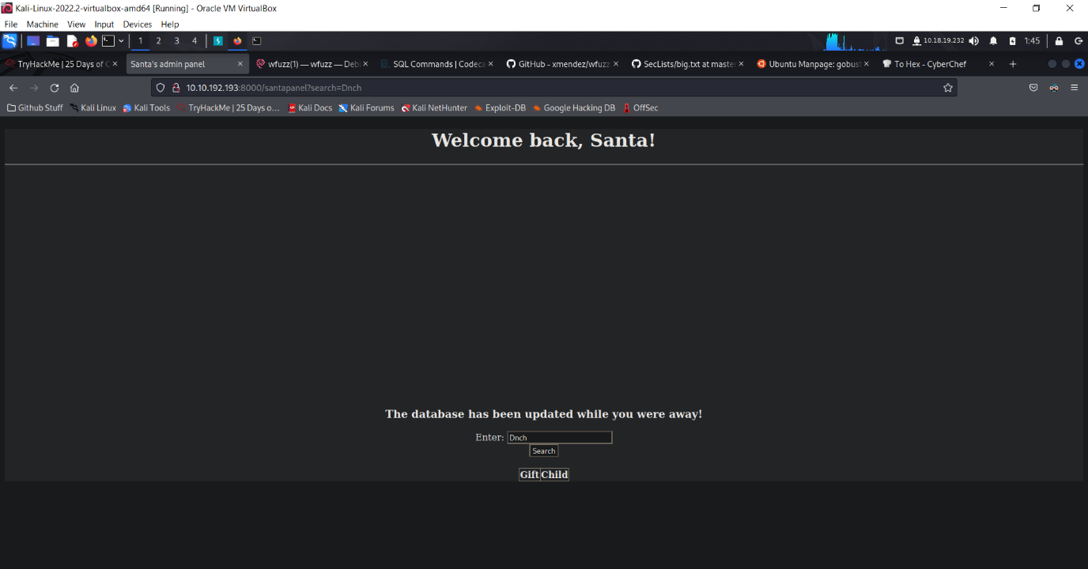After successfully tricking the system, we now entered into santa’s secret login panel.

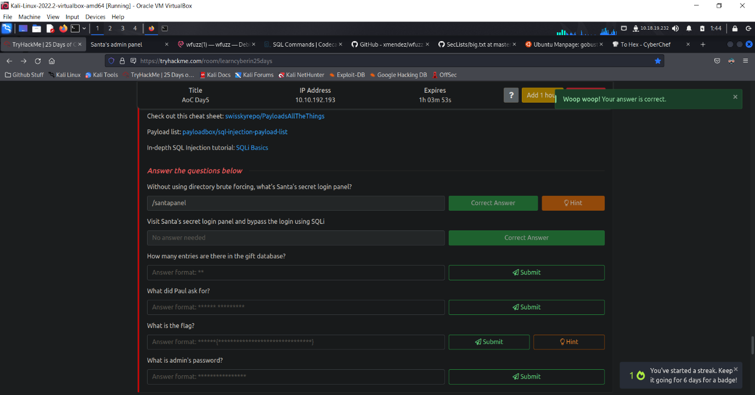Alright, before we proceed, let’s head to question 2 and click on the complete button to record our completion for question 2 as we have already successfully logging into santa’s secret login panel.

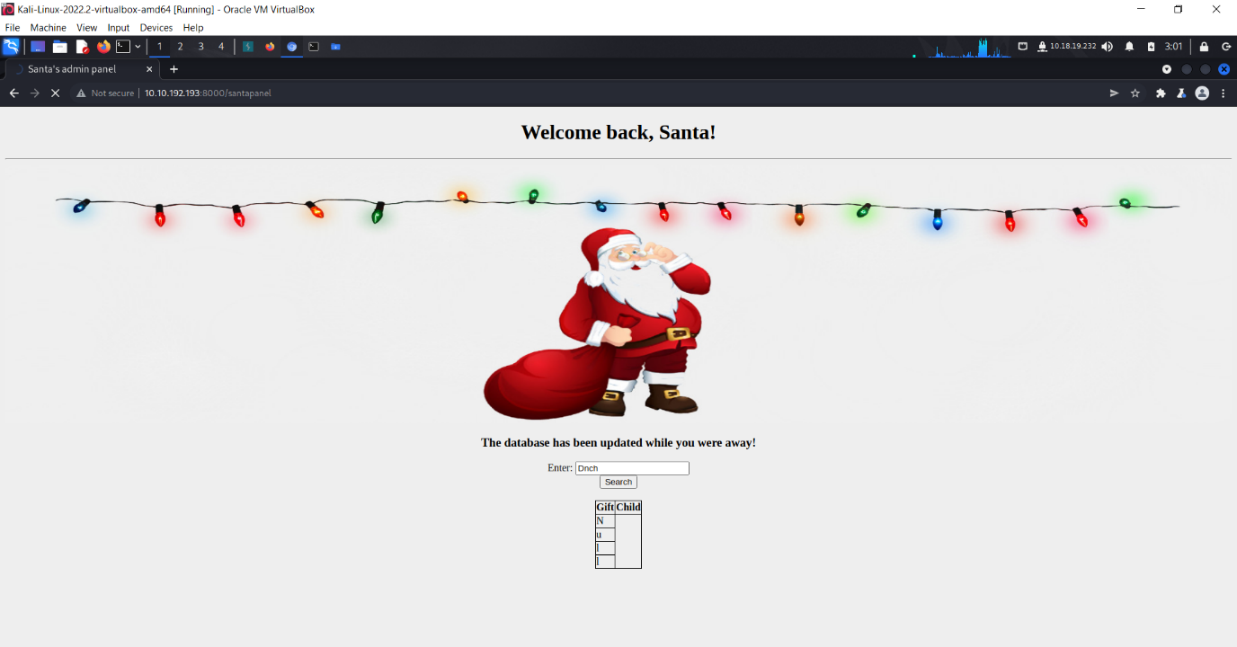After we are done with question 2, let’s head to Burpsuite and type in the Ip address with /santapanel following it behind.

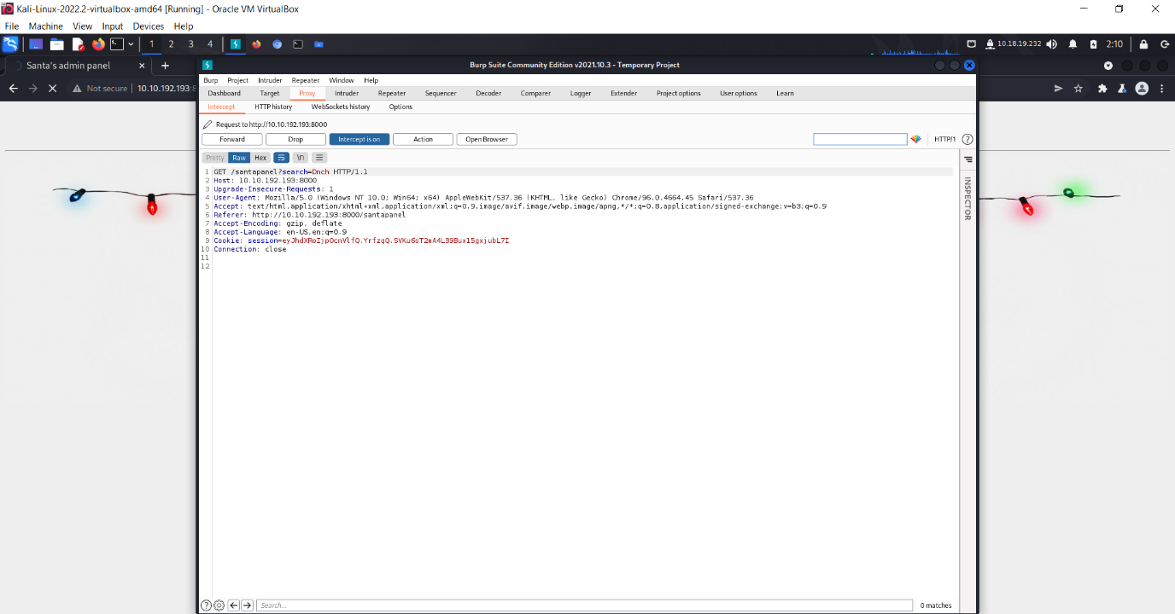After we typed in the Ip address in the search bar, we now have to turn on Burpsuite interceptor and start intercepting.

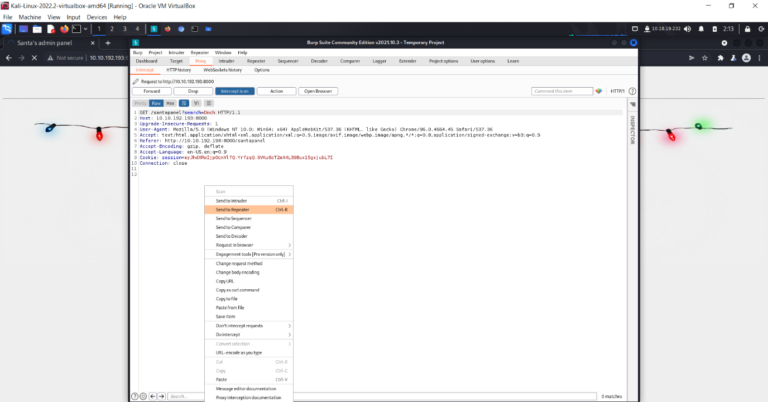After the intercept is on, right click it on any of the white spot and click send to repeater.

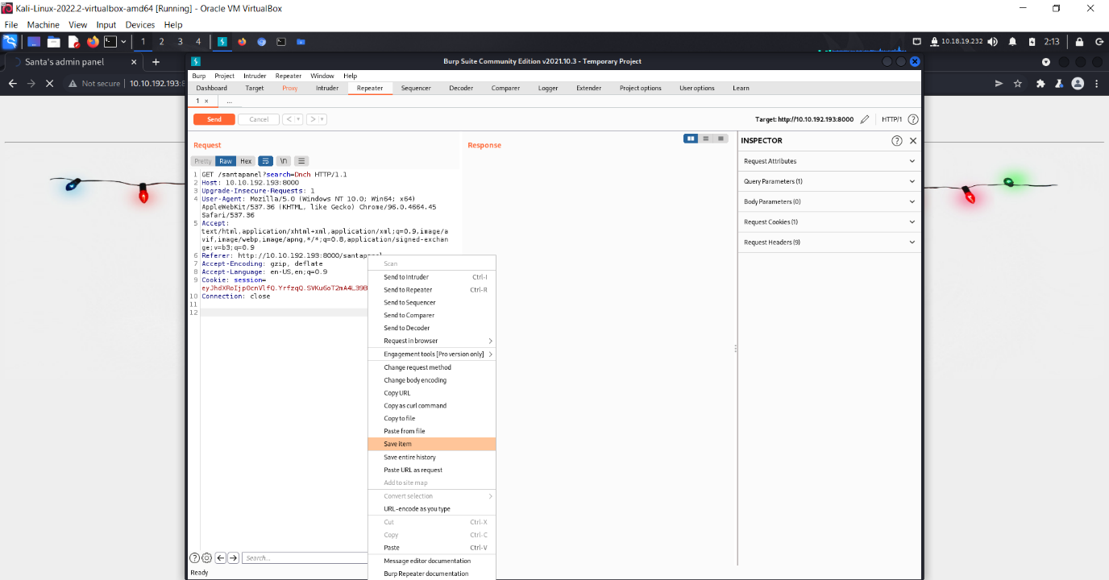Next, after clicking send to repeater, head to the repeater bar and then right click on any of the white spots and click save item.

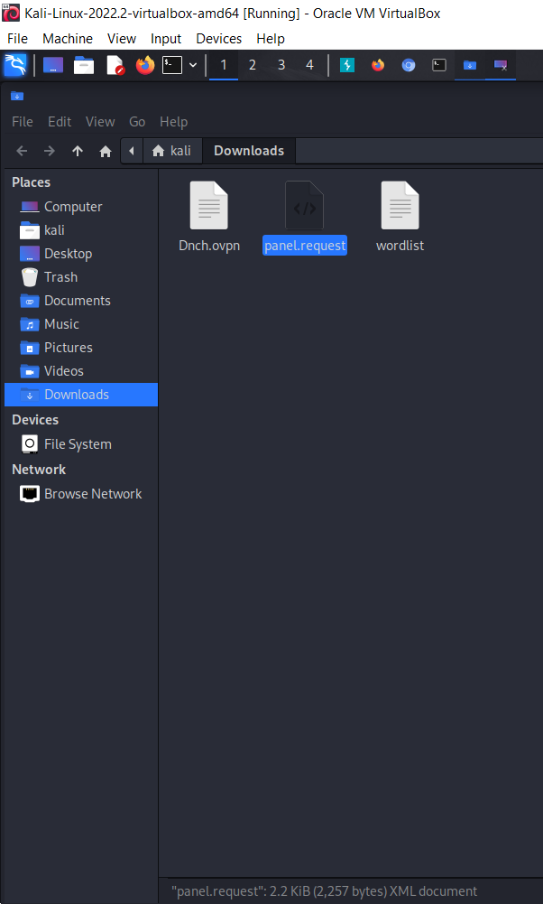

After clicking save item, it will pop up a notification saying where you want to save your file at. For me I saved it in Downloads so it’s easier for me to find and access to, and I name the file as panel.request.

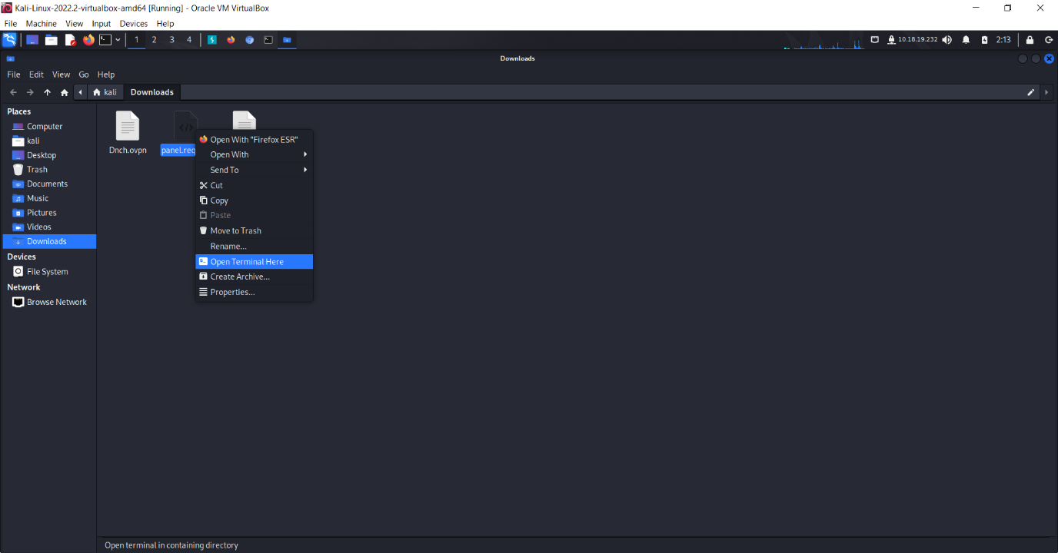So after saving it in Downloads, right click on the file and select open terminal here.

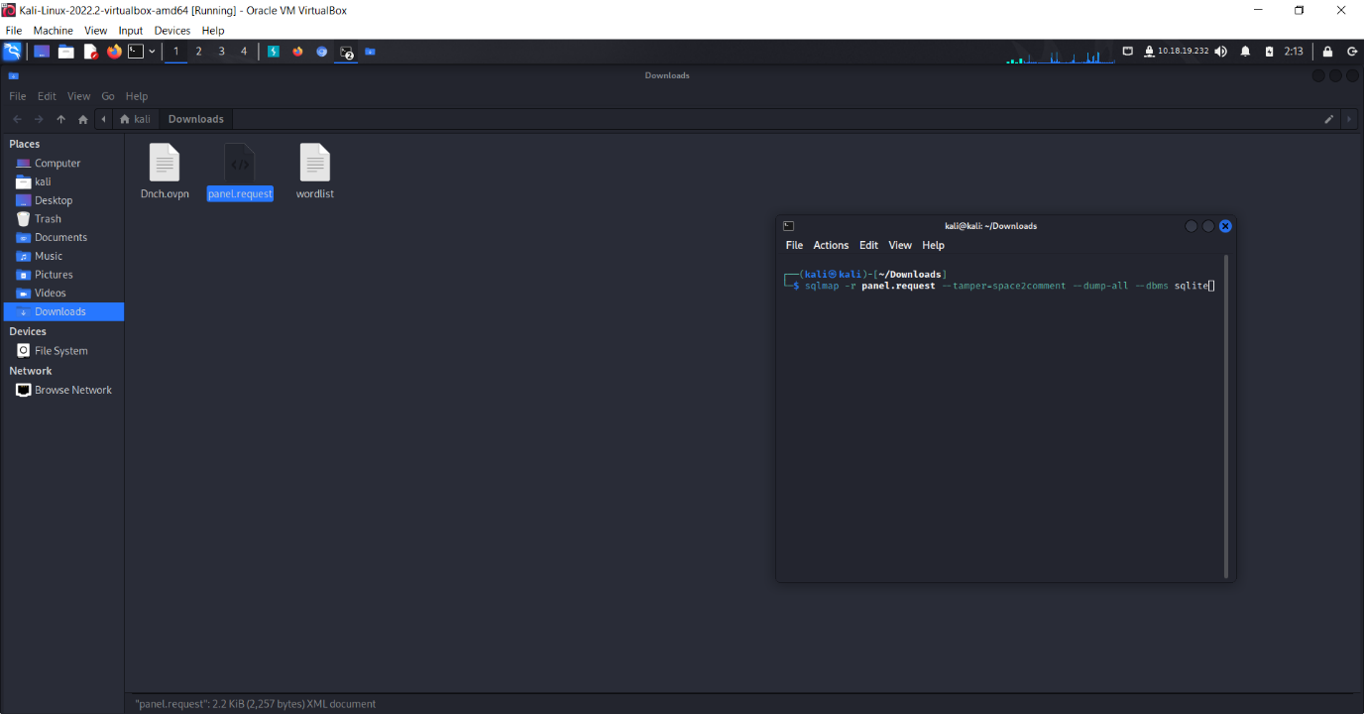 After opening the terminal, enter the command as shown above to get the answers for the last 4 questions in THM. The command for -r would be request, so by typing in sqlmap -r, it will automatically translate the request and exploit the database you want for you. Next, for the command --tamper=space2comment,It’s to tell SQLMap to try and bypass the WAF by using it. And for –dump -all, it’s to dump everything inside of the database and let’s you see what is inside of it after dumping. And lastly as for –dbms, it’s to tell SQLMap the type of database that is running, so that is why the commands goes like this as shown above in the picture.

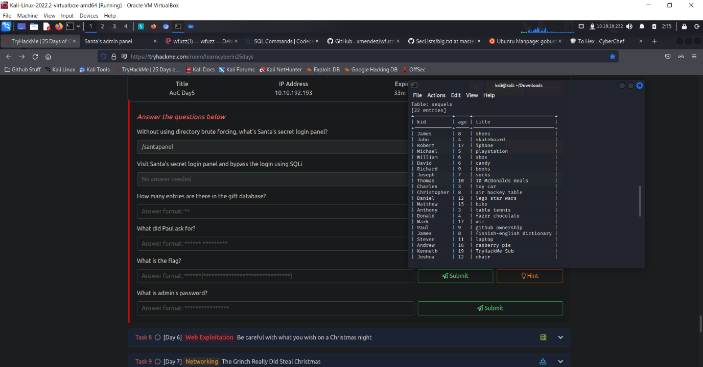

So after we entered the command and press enter, it will show us all the data inside of the database, so right now for question number 3, we can find the answer located inside of the terminal box, and the answer is 22. 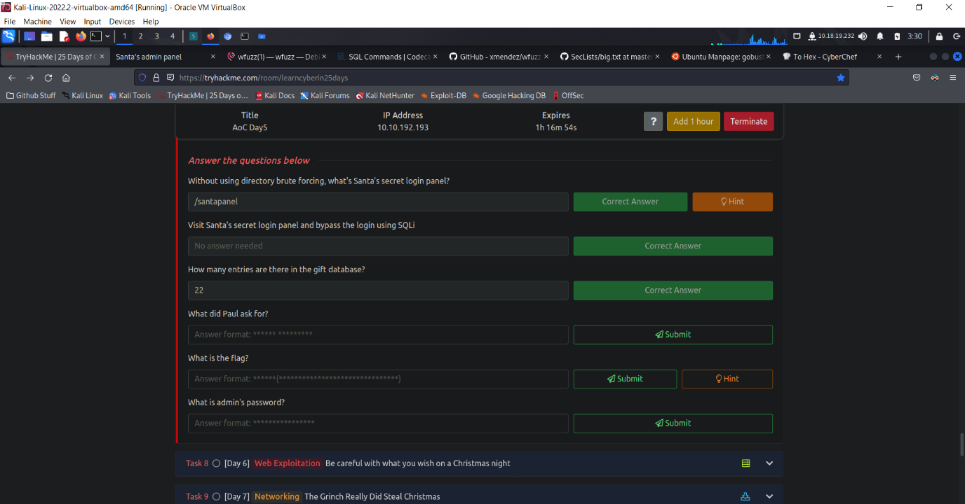

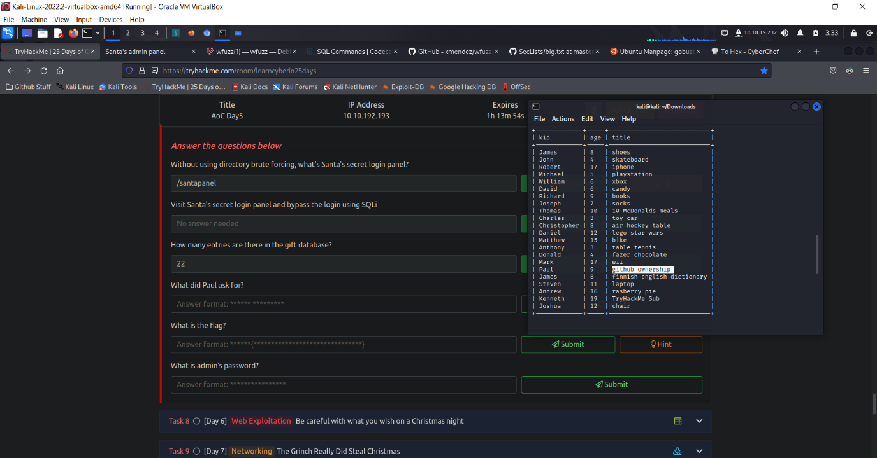Next, for question number 4, we are asked what did Paul asked for his Christmas present. So let’s eahd back to the terminal and we can find that Paul wanted to have a github ownership, so let’s put in the answer in the answer box and see if it’s correct. 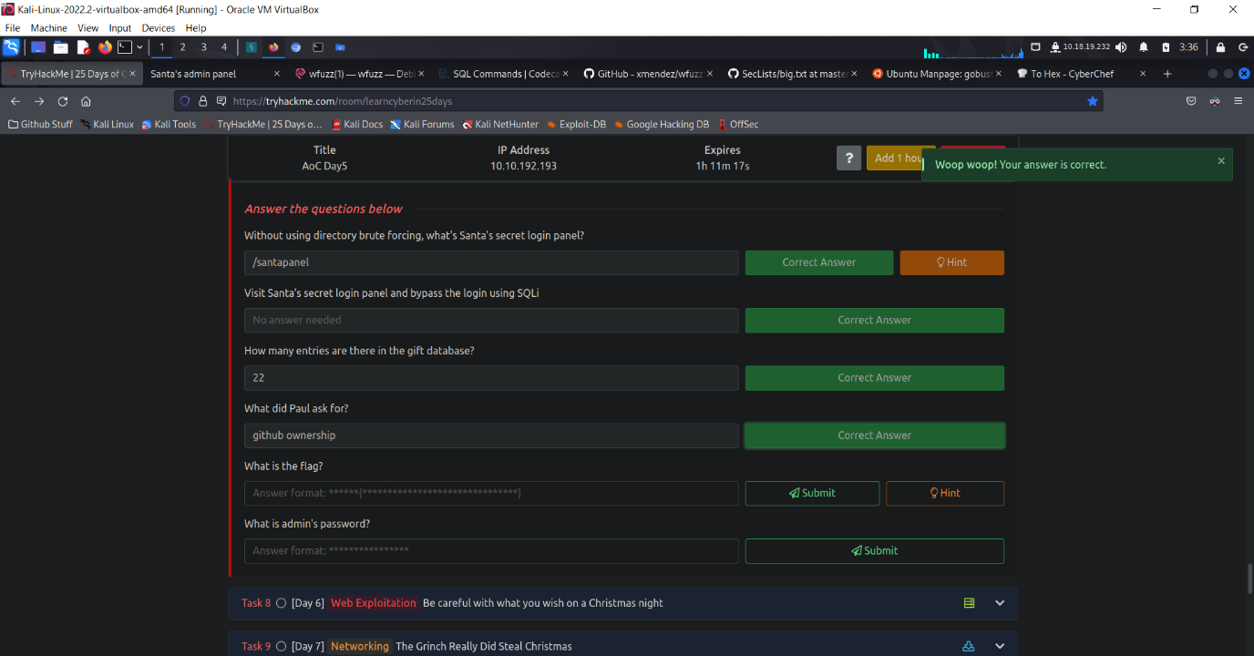 Well, looks like it’s correct already. Now on to the next one.

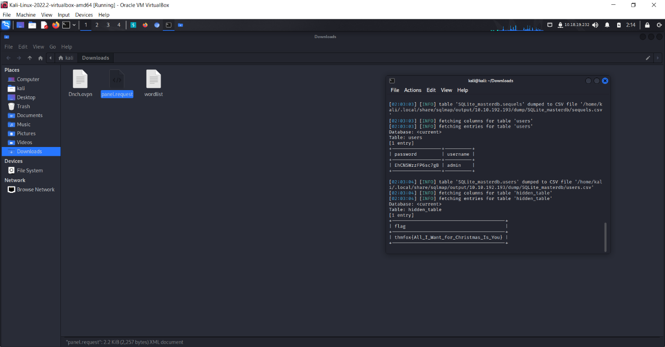Well, it seems like we have found the answer to both of the last questions.

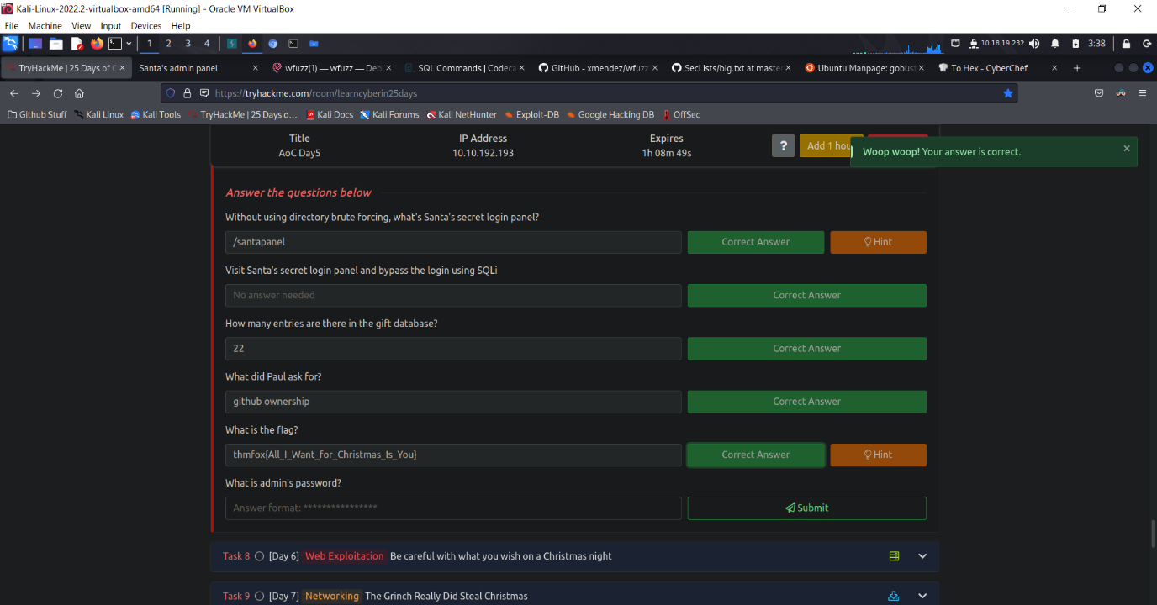

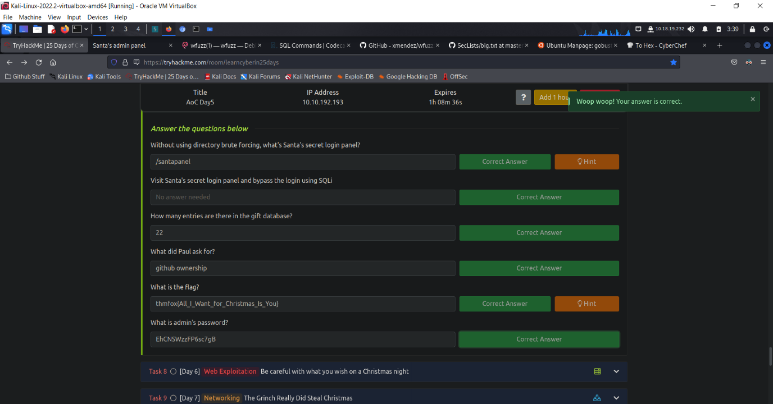 Alright, now we have enter the answers for the last two questions in Day 5, we have now officially completed our week 2 exercise.

End of Day 5 report